Barriers and Opportunities to Employment for Persons with Disabilities in the Russian Federation
Nina Kolybashkina, Anna Sukhova, Maria Ustinova, Anna Demianova, Daria Shubina

Relevance and purpose of the study
The main framework that informs global support policies for persons with disabilities is the United Nations Convention on the Rights of Persons with Disabilities (CRPD). The CRPD’s purpose is to promote, protect, and ensure the full and equal enjoyment of all human rights and fundamental freedoms by all persons with disabilities, and to promote respect for their inherent dignity and participation in labor market.
In 2012, the Russian Federation ratified the CRPD and began the process of aligning its legislation and policy measures with the convention. Measures to protect the rights of people with disabilities in the Russian Federation, special provisions regarding their employment as well as measures to increase their competitiveness in the labor market are include in the Russian legislation. In 2011 Russia launched the National Accessible Environment Program.
Despite the measures taken, the level of employment of people with disabilities in Russia remains low and does not increase. The employment rate among persons with disabilities in the Russian Federation was 26.3 percent as of 2021. At the same time one of the key performance indicators of the National Accessible Environment Program is that the employment rate among persons with disabilities reaches 41 percent by 2024.
The goal of the research is to identify the causes of low employment levels among people with disabilities and to explore to strengthen policy measures designed to improve the situation and better aligned them with CRPD principles. In anticipation of the next Russia report on the implementation of the provisions of the CRPD in 2022, the study is of particular relevance.

Methodology
In studies on Russia, the “weak” position of disabled people in the labor market is associated with a lower level of education [Yarskaya-Smirnova, Naberushkina, 2004], the existence of the physical environment barriers [Romanov, Yarskaya-Smirnova, 2006; Martz, 2008], employers' prejudices [Novozhilova, 2001], as well as low labor supply [Demianova A. V., Lukiyanova A. L., 2016]. The discrimination on the basis of disability in the labor market in Russia is indicated by the results of sociological surveys [Martz, 2008, Yarskaya-Smirnova, Naberushkina, 2009], as well as econometric estimates [Demianova A. V., Lukiyanova A. L., 2017]. However, no interdisciplinary research that includes the analysis of both quantitative and qualitative data on the participation of people with disabilities in the Russian labor market has been carried out previously. In addition, existing studies do not simultaneously take into account the opinion of all participants of employment process.
The assessment was based on a mixed-methods approach that combines legislation, quantitative and qualitative data analysis. The qualitative component consists of a series of expert interviews, focus group discussions, and roundtable consultations with researchers working in the field of disability studies; NGOs serving people with disabilities, organizations of people with disabilities; employers with experience in hiring candidates with disabilities, and people with disabilities. Quantitative data includes administrative and survey data collected by Rosstat and government agencies. The study was carried out by a multidisciplinary team of World Bank specialists with the participation of ROOI Perspektiva and the All-Russian Society of Disabled People.

Findings

a) The definition of disability and the system of collection and analysis of disability data need to be revised
The definition of a person with a disability under Russian draws on the medical model of disability and is not aligned with the United Nations Convention on the Rights of Persons with Disabilities (CRPD) because it does not address environmental and societal barriers.
Official statistics focus solely on people with a disability status; they do not include people who, for a variety of reasons are unable or unwilling to acquire disability status but who face limitations in daily life. This approach is not in line with CRPD and does not allow for international comparisons. Administrative PFR data also excludes a large group of people with disabilities who are in informal employment.
Furthermore, solely focusing on people below retirement age in social program excludes one-third of people with disabilities who are currently officially employed.

b) Policy measures should consider the diverse needs and potential career trajectories of different groups of people with disabilities based on age, gender, and health characteristics.
At the beginning of 2021, accoring to PFR data, about 1.5 million people with disabilities worked in Russia, a third of whom were persons of retirement age. The employment rate varies by group of disabilities. Among people with disabilities, those between the ages of 40 and 49, those with a higher education, and those living in rural areas have higher employment rates.
People with disabilities have less attractive jobs: they are more likely to work in the unincorporated sector or in lower-wage industries. They are less likely to be employed in positions requiring professional qualifications, and less often to work in their specialty. The distribution of wages for people with disabilities is skewed towards lower income groups.
The results of focus groups and interviews indicate that the environmental and social barriers contribute significantly to the low level of participation of people with disabilities in employment and the overall low integration of such people into society. They also limit the career opportunities for this population group.

c) The implementation of compensatory social protection measures for people with disabilities sometimes acts as a barrier to employment, in particular formal.
Disability status is awarded based on the Medical and Social Expertise procedure. The most part of persons with disability in the first years after a disability onset have to pass a re-examination in a year/ two years. Persons with a disability status receive a number of monetary and non-monetary benefits. Most of which do not depend on having a job. However, some of the payments are not provided to working people with disabilities or are not indexed if they have a job. This situation has a discouraging effect on the employment of this group.
In interviews and focus groups, it was revealed that the fear of losing or reducing the amount of support can persuade people with disabilities to seek for informal employment. In addition, individual plans for rehabilitation and habilitation, as well as recommendations on the forms of employment, are often viewed as a barrier to employment by all participants in the process: people with disabilities, employees of employment centers and employers themselves.

d) Policy measures to stimulate the demand for labor by people with disabilities among employers need to be revised
The system of quotas is the key measure of the state policy aimed at stimulating demand for the labor of people with disabilities. Findings from qualitative data reveal that the current system of quotas is not effective due to the underdeveloped system of financial incentives and the low prevalence of technical support measures for employers.
Data from interviews, focus groups and discussions showed that many employers lack information about the practical aspects of employing people with disabilities, they fear high additional costs, lawsuits and worry about special conditions that they cannot provide. It remains difficult to reconcile work requirements with the needs of people with disabilities.
Public support measures do not fully comply with the CRPD, as they do not take into account the individual characteristics and unique needs of each person with a disability. Figure 1 shows the identified barriers to increasing employment for people with disabilities, as well as factors that need to be taken into account for effective planning of government policies to promote employment of people with disabilities.

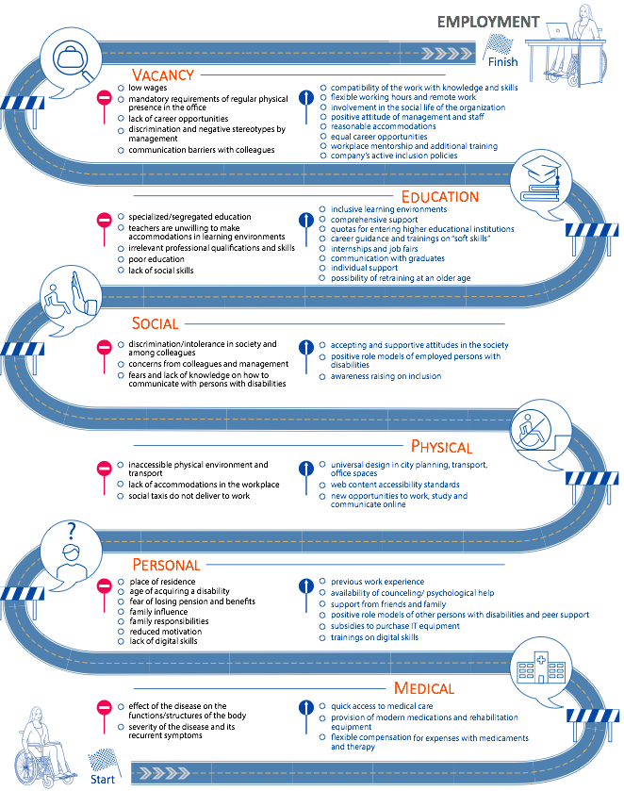
Figure 1. Factors influencing the employment of people with disabilities

World Bank, Senior Social Development Specialist
World Bank, Social Protection Specialist
World Bank, Consultant; NRU HSE, Analyst, Centre for Studies of Income and Living Standards ISP
World Bank, Consultant; NRU HSE, Deputy Director, Centre of Labour and Earnings Statistics ISSEK
World Bank, Consultant; Center for Advanced Governance, Head of the project "Sociology of Civil Service"

