NEW INSIGTS OF THE STRATEGIC CAPABILITIES CONCEPT

Entering new geographical markets can be a great way to grow for business and get higher return investment. All of that with the rapidly changing business environment have an impact on the business and forces companies to look for ways to improve its competitiveness. Therefore, the challenge for companies is to combine different types of resources, core competencies, and dynamic and other capabilities to gain competitive advantages.
Strategic capability is a new concept in strategic management that can combine all of the above terms and provide the basis for building strategic competitive advantage (London, Hart, 2004; Cuervo-Cazurra, Newburry, & Park, 2016; 2020). Strategic capabilities are the ones that need to be engaged in a company's attempts to be competitive in a rapidly changing environment. A company can have a stronger competitive position by identifying its strategic capabilities, matching them to its external environment, and integrating them into a strong strategy (Kumar, Simon, & Kimberley, 2000).
The development of the strategic capability concept faces a diversity of interpretations offered by different authors, as a result, the concepts introduced by the resource-based view (RBV) and its theoretical extensions (resources, processes, capabilities, competencies, etc.) lack clear definitions (Thomas & Pollock, 1999). The diversity of concepts affects the relationship between strategic capabilities and other company competitiveness concepts, which leads to misinterpretations of individual research results in a holistic view of company 'capabilities' research and to the development of research that focuses on single capabilities but not on complex analyses of them.
A review of the strategic capabilities concept and related theoretical concepts provides a more comprehensive and in-depth view of strategic capabilities. In order to understand the nature of a company’s strategic capabilities, it is important to examine its architecture (Pandza, Horsburgh, Gorton, & Polajnar, 2003; Vesalainen & Hakala, 2014). Most models addressing the capability hierarchy are four-level, including resources, operational and functional capabilities, core competencies, and dynamic capabilities (Sanchez & Heene, 1997; Teece et al., 1997; Hafeez, Zhang, & Malak, 2002; Mills, Platts, & Bourne, 2003; Sanchez, 2004; Wang & Ahmed, 2007; Wójcik, 2015; Thomas, 2016, Ceglinski, 2020). Also, special attention should be paid to the relationship between the concepts of strategic capabilities and dynamic capabilities when considering the capability hierarchy.
The different position of strategic capabilities compared to other concepts within the competitiveness and competitive advantage theory provides space for rethinking the existing strategic capabilities architecture of a company. Strategic capabilities include such key categories as unique resources, key competencies, and capabilities, and take into account the country context.
Understanding the market and adapting to its context can improve the efficiency of an organization and its product lifecycle, which can lead to a sustainable competitive advantage in the long-term (Jácome, Lisboa, & Yasin, 2002). Using this approach to identify and build a sustainable competitive advantage in the relevant industry is called “competing on capabilities” (Ghemawat, 1986; Stalk, Evans & Shulman, 1992; Kumar, Simon, & Kimberley, 2000; Simon & Power, 2004; Moffat & Simon, 2008).
The work is based on a meta-analysis of articles investigating strategic capabilities and their place in building company competitiveness. For the initial selection of studies, a search query was used by topic with a focus on a synonymous range of terms used to refer to the strategic capabilities concept and terms closely associated with the development of this concept - competitive advantage and company competitiveness.
As a result, 676 sources were found. Among the sources found were selected articles, which are focused on the compliance with the objectives of the meta-analysis and the level of works citations. On their basis various definitions of strategic capabilities, their review and their interrelation with the company competitiveness were analyzed, as well as various types of capabilities different from strategic ones were identified.
Rethinking the existing architecture of a company’s strategic capabilities allowed the authors to present their own vision of the relationship among resources, competencies, various types of capabilities, strategic capabilities, competitive advantages, and competitive performance (Figure 1). Strategic capabilities accumulate all the listed levels (resources, competencies, and capabilities) and build competitive advantage on their basis. This enables considering strategic capabilities as a driver of companies’ competitiveness.

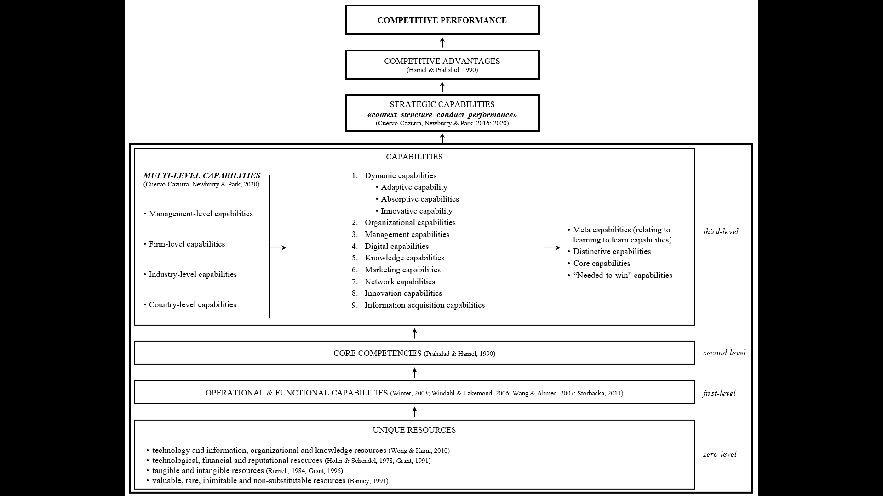
Figure 1: The Relationship between Strategic Capabilities, Competitive Advantage and Competitive Performance
The findings have academic value for further research on the companies' strategic capabilities. They allow linking different concepts forming the company's competitiveness and to approach its study in a more comprehensive way, taking strategic capabilities as a basis. The practical significance of the findings is that they can help managers better understand the sources of superior competitive performance and their interconnections and thus work to improve the companies' competitiveness in both local and global markets.

References
- Ceglinski P. The Relations between Dynamic Capabilities and Core Competencies on the Case of Polish Companies / P. Ceglinski // Administrative Sciences. – 2020. – №10(48). – P. 1-10.
- Cuervo-Cazurra A. Emerging Market Multinationals: Managing Operational Challenges for Sustained International Growth / A. Cuervo-Cazurra, W. Newburry, S. Park // Cambridge University Press. – 2016. – 220 p.
- Cuervo-Cazurra A. Building Strategic Capabilities in Emerging Markets / A. Cuervo-Cazurra, W. Newburry, S. Park // Cambridge University Press, 2020.
- Filatova M. V. Building and developing strategic potential for enterprises in the oil and fats industry. Unpublished doctoral dissertation, Voronezh State University of Engineering Technology, Voronezh, 2006.
- Helfat C. E., Winter S. G. Untangling dynamic and operational capabilities: Strategy for the (n)ever‐changing world / C. E. Helfat, S. G. Winter // Strategic Management Journal. – 2011. – №32(11). – P. 1243-1250.
- Johnson G. et al. Exploring Corporate Strategy / G. Johnson et al. – Pearson Education Limited, 2008.
- Mills J., Platts K., Bourne M. Competence and resource architectures / J. Mills, K. Platts, M. Bourne // International Journal of Operations & Production Management. – 2003. – №23(9). – P. 977-994.
- Moffat P., Simon A. 2008. Strategic management capabilities that drive west Australian law firm success. In CD proceedings M. Wilson (Ed.), 22nd ANZAM Conference 2008 'Managing in the Pacific Century. Australian and New Zealand Academy of Management.
- Pandza K., Horsburgh S., Gorton K., & Polajnar A. A real options approach to managing resources and capabilities / K. Pandza, S. Horsburgh, K. Gorton, A. Polajnar // International Journal of Operations & Production Management. – 2003. – №23(9). – P. 1010-1032.
- Patrakhina T. N. Organizational strategic potential: Russian and foreign approaches / T. N. Patrakhina // Molodoy ucheniy. – 2015 – №6. – P. 442-444.
- Sanchez R. Understanding competence-based management. Identifying and managing five modes of competence / R. Sanchez // Journal of Business Research. 2004. – №57. – P. 518-532.
- Teece D. J. Dynamic capabilities: Routines versus entrepreneurial action / D. J. Teece // Journal of Management Studies. – 2012. – №49(8). – P. 1395-1401.
- Thomas J. Strategic Management / J. Thomas. – Pearson, 2016.
- Vesalainen J. Strategic capability architecture: The role of network capability / J. Vesalainen, H. Hakala // Industrial Marketing Management. – 2014. – №43(6). – P.938-950.
- Wang C. L., Ahmed P. K. Dynamic capabilities: A review and research agenda / C. L. Wang, P. K. Ahmed // International Journal of Management Reviews. 2007. – №9(1). – P. 31-51.
- Wójcik P. Exploring Links Between Dynamic Capabilities Perspective and Resource-Based View: A Literature Overview / P. Wójcik // International Journal of Management and Economics. – 2015. – №45. – P. 83-107.

