The influence of bonding social capital on economic growth
The influence of social capital (following L. Guiso, P. Sapiens and L. Zingales (Luigi Guiso et al., 2011), social capital are persistent and widespread beliefs and values ​​that help society to overcome the «free rider problem ») is currently attracting the attention of economists all over the world. There are several achievements in this area: methods for measuring values ​​and behavioral attitudes have appeared, statistical tools have been developed for identifying and assessing the effects of culture. Numerous studies suggest that variables related to social capital and culture have an impact on economic performance (Alesina & Giuliano, 2015; Algan & Cahuc, 2014; L Guiso et al., 2004).
However, despite the vast amount of work in this area, there are numerous issuers. First, the literature pays insufficient attention to the variables related to bonding social capital - values ​​and attitudes that apply to a particular social group and that help group to overcome the «free rider problem»). Second, authors usually assume a homogeneous effect - that is, it is assumed that culture plays the same role in the economic development in different countries and territories. At the same time, more and more empirical and theoretical studies postulate the presence of a heterogeneous effect: a situation in which the effect of a phenomenon (including culture) depends on the state of another factor. There is evidence of important role of the institutional environment (formal institutions) in determining the influence of social capital (Menyashev & Polishchuk, 2011). Third, the task of assessing the socio-cultural potential at the regional level is becoming more and more urgent (Bryzgalin & Nikishina, 2020).
The main purpose of this study is to assess the impact of bonding social capital on economic growth and identify the key channels of this process. The work continues the scientific tradition of studying the influence of social capital on economic growth by such economists as S. Knack, P. Keefer, P. Zak. J. Algan, P. Cahuc and others.
As part of the study, a database was collected with the socio-cultural and economic characteristics of the regions. Data from the World Values ​​Survey and the European Values ​​Survey (WVS / EVS) were disaggregated to the regional level, and the regions themselves were linked to a panel containing regional socio-economic data. The result was a database of cultural and socio-economic indicators for 1321 regions from 69 countries. There are panel data for most regions from 1981 to 2010. I also collected data on the quality of the institutional environment in the countries (the Rule of Law indicator from the World Bank and the Law and Order indicator from the ICRG database).
Using economic growth models, econometric models that take into account the presence of a heterogeneous effect, works that assessing the role of culture in the economy, I propose a model to assess the effects of bonding social capital during a sharp change in the institutional environment.
The results show that bonding social capital is a substitute for formal institutions: in the short term it contributes to economic growth when formal institutions deteriorate and hinders economic growth when formal institutions improve (Figure 1). Thus, the positive effect of improving the quality of institutions on economic growth is much stronger in regions with a low stock of bonding social capital and insignificant in regions with a high stock of bonding social capital. The deterioration in the quality of institutions has a neutral effect on economic growth in regions with a high level of closed social capital and negative effect in regions with a low level of bonding social capital.
Figure 1. Annual GDP per capita growth in regions and institutional shocks – the role of bonding social capital
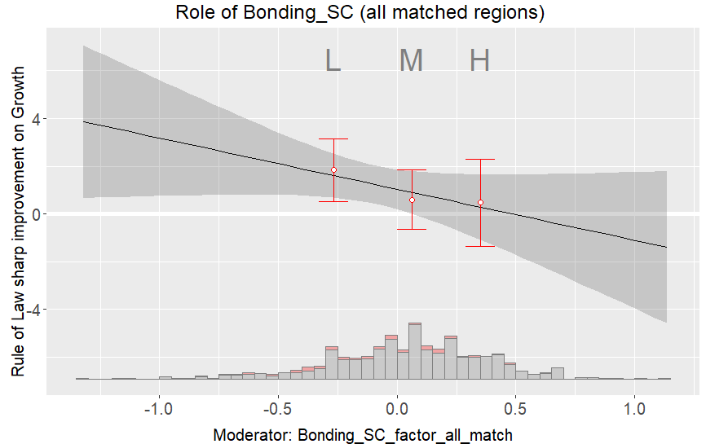 | 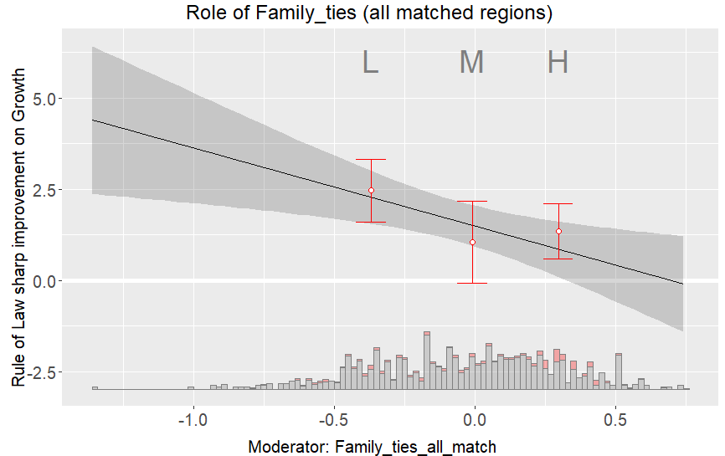
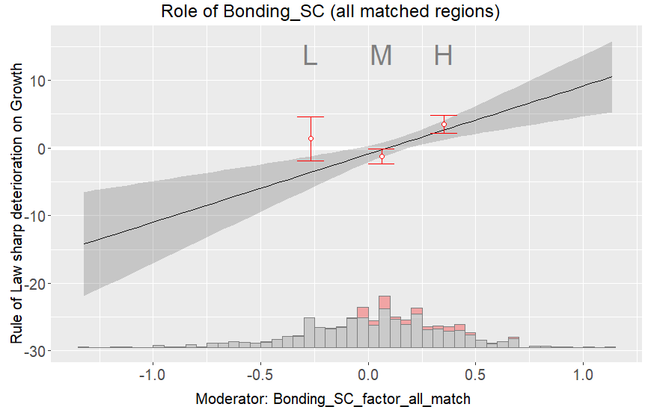 | 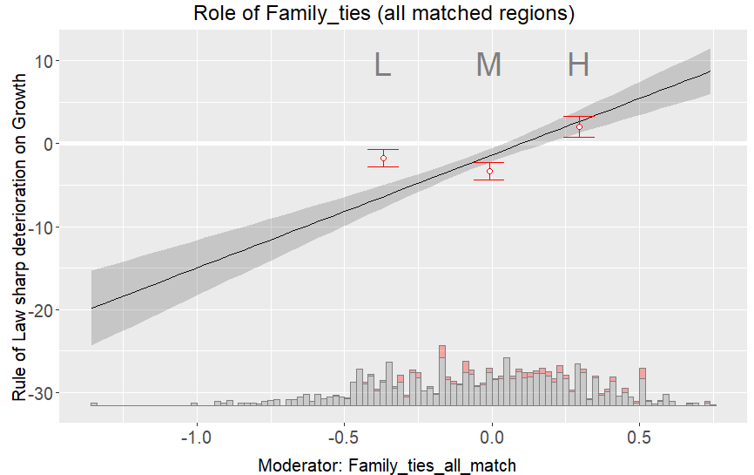
Source: author’s calculations
The result shows the significant role of bonding social capital in the economic growth process in the short term and shows that it is primarily appear through interaction with formal institutions (the quality of the institutional environment).

