Anna MIKHAYLOVA, PhD, Russian Presidential Academy of National Economy and Public Administration (Moscow, Russia)
Evgeny TIMUSHEV, PhD, Federal research center Komi scientific center of the Ural branch of the Russian Academy of Sciences (Syktyvkar, Russia)

Vertical Fiscal Imbalance and Debt Sustainability of Russian Regions after 2020: Analysis of the Relationship Using Credit Ratings

Region’s debt sustainability attracts special attention during periods of sharp increase in uncertainty. The increase in federal transfers, which made it possible to significantly reduce the need of Russian regions for debt financing in 2020, affected the fiscal incentives of the regional authorities. An indicator of vertical fiscal imbalance (VFI) can help assess the state of fiscal sustainability and the state of intergovernmental fiscal relations. The advantage of VFI is precisely that it allows one to obtain a quantitative characterization of the vertical distribution of powers, to come closer to understanding fiscal incentives and the institutional conditions that cause them.
Debt sustainability assessment, quantified in the form of a credit rating, depends on the methodology for its assignment. Previously, we managed to determine that national rating agencies (ACRA and ExpertRA), when making a rating, are guided mainly by the values of quantitative budget indicators, and the debt sustainability of the Russian region, quantitatively assessed by the credit rating, can be modeled using three indicators - indicators of tax and non-tax revenues, capital expenditures and debt.
However, the relationship between debt sustainability and its factors with the vertical fiscal imbalance indicator remains a poorly understood area of public finance. The purpose of this work is to clarify the role of vertical fiscal imbalance and its components in shaping the debt sustainability of regions.
Vertical fiscal imbalance is higher in more subsidized regions of Russia. Methodologically, more stable results are provided by the analysis of vertical fiscal imbalance, "cleared" of incoming and outgoing subventions.
The average values of regional vertical fiscal imbalance in the world are highly differentiated, however, VFI is inversely related to the level of income in the economy of the region (Figure 1). In Russia and Canada, this pattern is most pronounced.

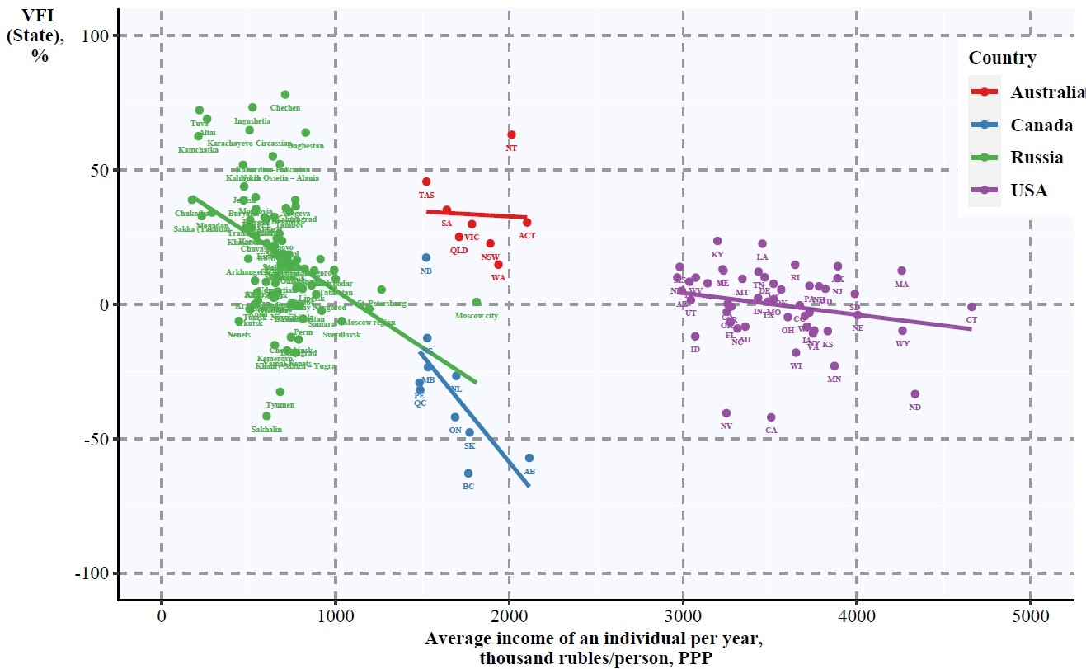Note: Compiled using average data for 2011–2018 (Australia for 2018–2020).

Picture 1 –Vertical fiscal imbalance of budgets and the level of income in the regions of the federal states of the world

When modeling the level of debt sustainability of a region in the form of a credit rating, calculations for Russian regions indicate the legitimacy of replacing the indicator of tax and non-tax budget revenues with an indicator of vertical fiscal imbalance (the latter is adjusted for subventions). At the same time, the ratings of the U.S. States from the S&P are much more difficult to model in this way, which indicates the limited vertical fiscal imbalance in this interpretation of debt sustainability and confirms the differences in rating approaches on the part of various agencies.
According to our calculations, the vertical fiscal imbalance of Russian regions increases as the rating and debt sustainability deteriorate. At the same time, the main driver of high vertical fiscal imbalance is not the budget deficit, but the balance of incoming and outgoing intergovernmental fiscal transfers.
In 2020, the balance of incoming and outgoing intergovernmental fiscal transfers of regions shifted in favor of the former, and this happened equally in the budget systems of all regions, regardless of the group (Figure 2). In regions rated A and AA, the events of 2020 and an unprecedented increase in federal transfers influenced the fact that the volume of incoming transfers exceeded the volume of outgoing ones.
The excess of federal intergovernmental fiscal transfers over regional ones in 2020 was ensured through subsidies. However, unlike federal subsidies, the growth of regional subsidies was almost imperceptible. In regions with a credit rating of A, AA, and AAA, the size of regional equalization subsidies is usually higher or approximately equal to the amount of federal subsidies received, while less stable constituent entities of the Russian Federation receive a significantly larger amount of equalization grants from the federal budget, in comparison with that which is distributed among local budgets. Unlike subsidies for equalization, the regions use grants for balancing relatively reluctantly - compared to federal subsidies, the amount of grants for balancing from the budgets of the constituent entities of the Russian Federation is noticeably smaller.

Source: authors' calculations based on data from the Russian Treasury.
Note: Credit rating data from ACRA: May - October 2021. Adjusted to 2017 prices, taking into account the budget expenditures index.

Picture 2 –Dynamics of the balance and structure of outgoing and outgoing intergovernmental fiscal transfers of Russian regions, thousand rubles / person

Thus, vertical fiscal imbalance occupies an important place among indicators of intergovernmental fiscal relations and, under certain conditions, can be considered a reliable determinant of debt sustainability. We conclude that when assessing debt sustainability, it is necessary to analyze the state of intergovernmental fiscal relations not only between federal and regional authorities, but also between regional authorities and municipal administrations.

The report was prepared as part of the implementation of the state task of the RANEPA for 2022.
Aldasoro I., Seiferling M. Vertical Fiscal Imbalances and the Accumulation of Government Debt // IMF Working Papers, 2014, 14/209. doi: 10.5089/9781484357552.001.
Mikhaylova A.A., Timushev E.N. Determinants of credit ratings of regions of Russia // Regionology. 2021. Volume 29, No. 2. P. 355–379. https://doi.org/10.15507/2413-1407.115.029.202102.355-379.
Mikhaylova A.A., Timushev E.N. The creditworthiness of the regions of Russia: what to look for // Financial Journal. 2020. No. 6. P. 69–86. https://doi.org/10.31107/2075-1990-2020-6-69-86

