The concept of resilience as a new methodological approach to sustainability of economic systems

Nataliya Smorodinskaya (Institute of Economics, RAS)

By the 2020s, the distributed model of production through global value chains (GVCs) has fundamentally increased the trade and production interdependences of national economies. The related analysis suggests that local shocks occurring at the level of supplier firms in any of the three global hubs of the GVCs’ intersection (China, Germany and the USA), as well as in Japan or Korea, can lead to cascading output losses in all major economies across the world, including the developing ones (Smorodinskaya & Katukov 2021a). Indeed, temporary lockdowns in Chinese Wuhan had caused the collapse of the just-in-time supply system through GVCs, thus generating a rolling deployment of the 2020 global recession - a historically record one in terms of its depth and the number of synchronic national downfalls (World Bank 2020). Contrary to apprehensions, the COVID-19 pandemic shock did not disrupt the globalized production, but rather manifested the entry of the world economy into the age of radical uncertainty and unpredictable risks (PIIE 2021).
A new type of risks, where local shocks generate devastating global implications, does not fit into traditional perceptions of economic systems’ sustainability. As a result, starting from the 2020s, a different idea of sustainability has come to the fore, associated with building up systems’ resilience.
The concept of economic resilience originates from the evolutionary paradigm and the complexity economics. The latter views economies as complex adaptive systems, or ecosystems of network interactions among agents and their groups (Mitchell 2009). Unlike traditional systems, ecosystems behave in a non-linear and unpredictable way, sustaining their holistic integrity by means of continual structural transformations. Resilience is a manifestation of this dynamic sustainability (or "moving equilibrium"), reflecting the adaptability of complex systems to situations of sudden shocks and prolonged stress. According to the OECD, resilience is the ability of a system (from a firm to the global economy) to flexibly recombine its elements and key resources for achieving dynamic equilibrium at a new development level in response to sudden internal or external disturbances (OECD, SIDA 2017).
The concept of resilience makes it possible to analyze both the behavior of economies in the age of uncertainty and the systemic risks arising from their increased interconnectedness (OECD 2020). Systemic risk refers to situations when a local event occurring in a certain link of the system or outside it generates cascading disruptions in the entire system as a whole, with the degree of damage these disruptions cause and their irreversible structural impacts on the system being as unpredictable as the local event itself (Linkov et al 2019).
According to resilient approach, in order to sustain sustainability in a global volatile environment, economies should keep to the following principles (Smorodinskaya & Katukov 2021a; 2021b; Smorodinskaya & Malygin 2021):
1) resilience of an economy results from keeping a dynamic balance between its two structural properties — robustness and flexibility. Robustness implies the ability of a system to remain structurally stable under shocks, while minimizing their negative impact on the overall performance. Flexibility, on the other hand, implies the system’s ability to quickly reconfigure its structure for adapting to post-shock changes in the environment. Simply put, a resilient system must be typically robust enough to safely absorb shocks, and simultaneously, flexible enough to perform a restorative structural maneuver and continue effective growth in a changed environment;
2) in the world of complexity and unpredictable risks, the traditional striving of systems for maximum efficiency with minimum current costs (the principle of "leanness") gives way to the priority of sustaining a dynamic balance between current efficiency and long-term resilience. The resilience-based efficiency requires not so much lean but rather adaptive behavior, implying in particular investments in building current redundancy, i.e., various surplus assets and reserve facilities that could be activated for the purpose of structural maneuver in case of a shock;
3) the degree of resilience largely depends on the level of complexity achieved by the economy both in organizational terms (enhancing network interactions and feedbacks) and in functional ones (diversification of production and exports). The most resilient and innovative are democratic countries with complex economies (USA, Japan, Germany, etc.): having both high production robustness and high network flexibility, they can successfully absorb shocks and quickly restore the after-shock productivity growth. Meanwhile, large hierarchies like China, while enjoying significant robustness, are not flexible enough due to weak feedbacks, thereby yielding in resilience even to small post-Soviet European economies that run low robustness but a growing flexibility (Root 2020). And resource-dependent and highly centralized hierarchies like Russia may run a decreasing complexity, both organizational and functional, which enlarges their fragility to the next powerful shocks;
4) enhancing resilience allows the economy to absorb unpredictable risks without stopping growth. Moreover, this process is dynamic, covering the functional and the behavioral changes in the system before the beginning of, during and after a sudden shock, i.e., at all four stages of transformation and corresponding growth policy (see Fig.). The last stage expresses the essence of the resilient approach: to survive in the world of uncertainty, the latter should be utilized as a development factor. The system must not only make a quick recovery rebound after a shock, but also prepare for the next shocks, i.e., make a leap forward using shocks as a 'window of opportunity' for restructuring and transition to a higher development level. It is in the instability phase (as the entropy and the degree of diversity increases), when the system accumulates new opportunities and makes a choice of further trajectory from many probable ones (Mitchell 2009). The policy of improving institutional and network environments can set favorable conditions for optimizing this selection. Therefore, multi-agent modeling and other methods for designing the desired future, based on the evolutionary holism, are gradually acquiring the status of mainstream (Hodgson 2020).

Fig. Stages of enhancing the economy's resilience to sudden shocks

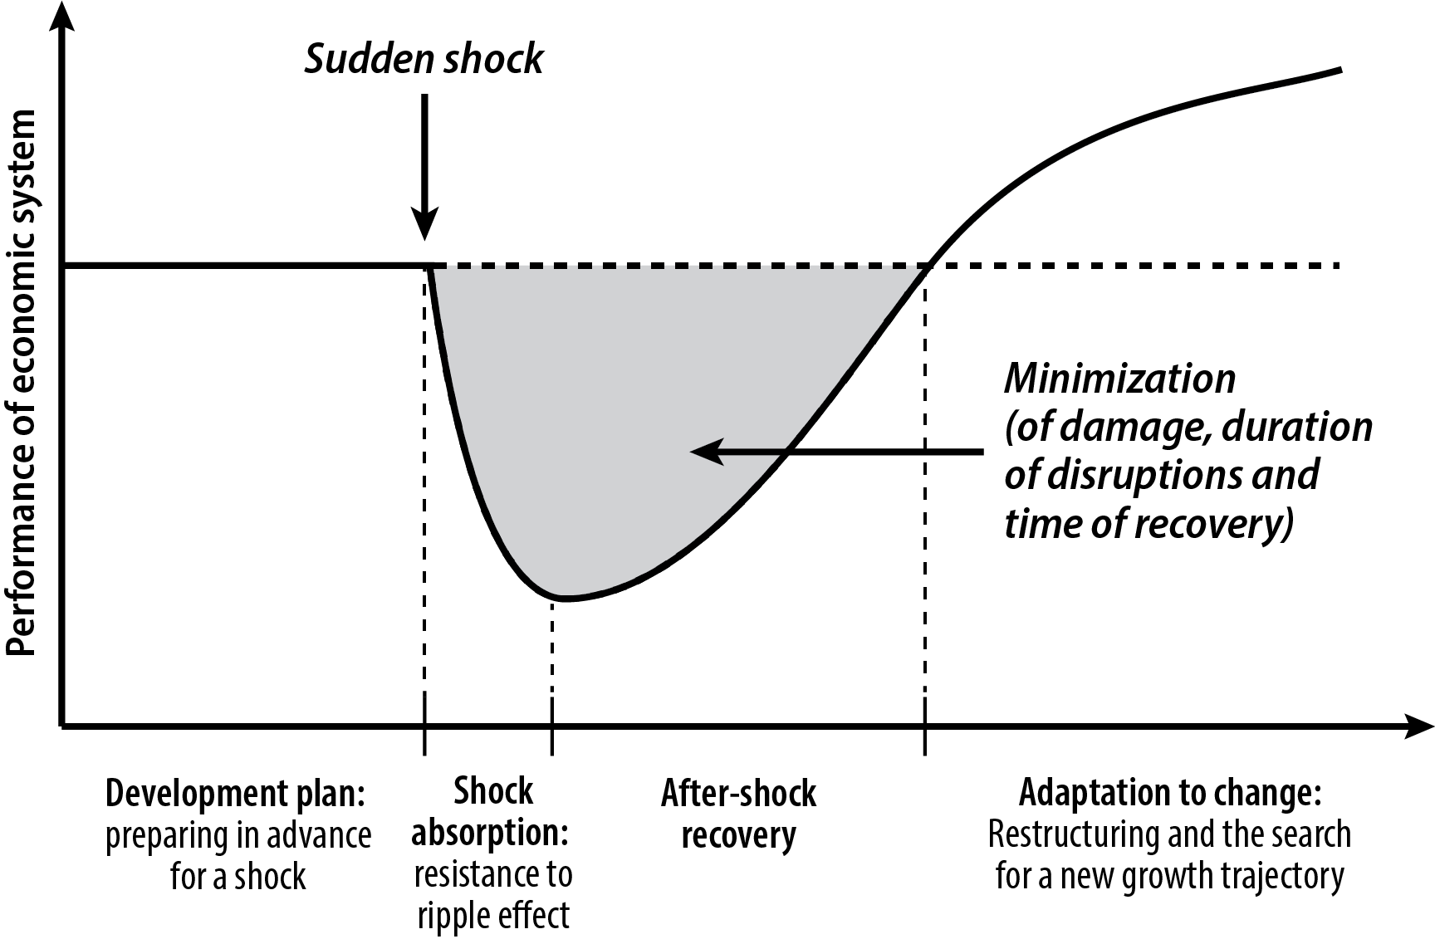

Source: based on Linkov et al 2019

Thus, resilience should be viewed as a functional pattern of complex systems, a new element of modern growth policy, and a new standard for risk management in the times of uncertainty

