Evaluation of the efficiency of the functioning of the Federal Center for High Medical Technologies in the profile "cardiovascular surgery" in the Penza region

Laboratory of Data Analysis and Applied Econometric Research of FEFU SHEM
A.E. Drozd
drozd.ae@dvfu.ru

Research problem
Cost- efficiency analysis is necessary for healthcare management in conditions of limited resources, i.e. when it is required to achieve maximum results at minimal cost. After all, the state invests certain funds in healthcare, in the implementation of prevention, diagnosis, treatment and rehabilitation, and therefore it is important for the Government of the Russian Federation to understand how effectively they are used. However, in reality, one can observe how morbidity and mortality vary widely by region. Therefore, the question arises: how to evaluate and explain the efficiency of political intervention? In this study, an attempt was made to evaluate the efficiency of the functioning of the Federal Center for High medical Technologies in the profile "cardiovascular surgery" in the Penza region using a synthetic control method. The model took into account the influence of factors that have a theoretical mechanism of influence on cardiovascular diseases. Placebo tests were also conducted to verify the reliability of the model.

Data and models
In this study, the efficiency of the functioning of the Federal Center for High Technologies in the profile "cardiovascular surgery" in the Penza region and its impact on the incidence of the cardiovascular system per 1000 people was evaluated (data from 2004 to 2020). The reason for choosing this area is that the center in this subject began its detail first. Most of the centers began to be operated only in 2010, and in 2011-2012 a Program of modernization of healthcare was adopted, which may also have influenced the reduction of morbidity. The efficiency will be assessed using the econometric method of data analysis - synthetic control. The effect of the political intervention under study will be analyzed by modeling effects in a hypothetical situation where no impact was made, based on a limited number of similar control observations (pool of donors) by assigning certain weights to these variables. The effect of the studied effect is denoted as a_{it} and calculated by the formula a_{it} = $Y_{it}^{I}$-$Y_{it}^{N}$where i is the region, t is the time period, $Y_{it}^{I}$is the indicator observed in the region (incidence of CVD per 1000 people in the Penza region), $Y_{it}^{N}$is the response of the indicator in the absence of the Federal Center for High medical technologies. $Y_{it}^{I}$=$Y_{it}^{N}$ before the Federal Center for High Medical Technologies began functioning, where t = 1…T₀ and T₀ is the number of periods before exposure (1≤T0 <T). The impact occurs only in i=1 and t>T₀, respectively, a_{1t}=$Y_{1t}^{I}$-$Y_{1t}^{N}$, where $Y_{1t}^{I}$ is the incidence of CVD per 1000 people in the observed subject of the Russian Federation, $Y_{1t}^{N}$is an unobservable response, which can be represented as the following factor model: $Y_{1t}^{N}$ = $δ_{t}+θZ_{i}+λ_{t}μ_{i}+ε_{it}$, where $δ_{t}$is a factor common to all regions, $θZ_{i}$is a vector of observed covariates independent of the impact, $λ_{t}$ is a vector of unobservable latent factors, $μ_{i}$is a vector of factor loads corresponding to them, $ε_{it}$is specificity, or noise. This model can be transformed and a new estimate of the impact effect can be obtained ${\hat{a}}_{1t}$= Y_{1t} -$\sum_{j}{{\tilde{w}}_{j}}Y$_{jt}, where ${\tilde{w}}_{j}$is a weight that allows you to accurately model the variables of the observed subject of the Russian Federation through the variables of subjects from the donor pool.
As for the factors explaining the incidence of CVD per 100 people, the literature related to the influence of one or another factor on CVD was analyzed:
the proportion of poor;
- proportion of older people;
- consumption of tobacco products;
- percentage of urban population;
- the ratio of men and women;
- marriage rate;
- breeding capacity;
- real income per capita;
- education level;
- air pollution;
- water pollution;
- propensity to blood diseases;
- tendency to diseases of the endocrine system;
- propensity to diseases of the nervous system;
- propensity to diseases of the digestive system.
The pool of donors included a set of regions that were not exposed to any similar effects both before and after the start of the operation of the federal Center for High Medical Technologies. The pool of donors includes all subjects of the Russian Federation with the exception of six regions where centers were built:
1. Astrakhan region;
2. Kaliningrad region;
3. Krasnoyarsk region;
4. Perm region;
5. Khabarovsk region;
6. Chelyabinsk region.

Results and discussion. Figure 1 shows the values of variables for the Penza region, for synthetics and on average for Russia.

Source: compiled by the author
Fig. 1. Values of variables for the Penza region, for synthetics and on average in Russia

It can be see from the figure that the values of synthetic factors practically coincide with the actual Penza region. Further, weights were calculated that could more accurately reflect the trend of the real region (Altai Territory - 0.277, Ivanovo region - 0.123, Republic of Mordovia - 0.061, Omsk region - 0.120, Tambov region - 0.149, Tula region - 0.271).
Figure 2 shows the trend in the incidence of CVD per 1000 people in the Penza region and its synthetic control from 2004 to 2020.
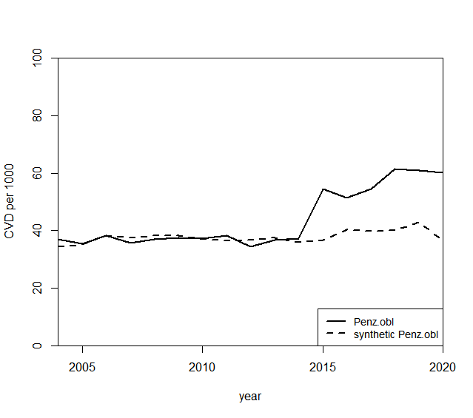
Source: compiled by the author
Fig. 2. The trend in the incidence of CVD per 1000 people in the Penza region and its synthetic control from 2004 to 2020.

The trends of the real region and its synthetics in the period before the federal center began functioning (2008) practically coincided. However, after commissioning, the trend lines did not change their direction. This result can be interpreted as the absence of any effect from the introduction of this center in the Penza region
Figure 3 shows the gaps between the values of morbidity in the Penza region and synthetic control.
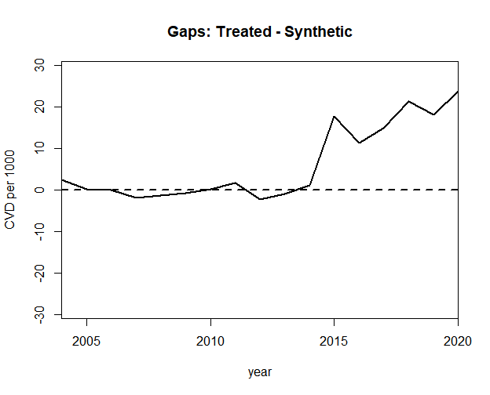
Source: compiled by the author
Fig. 3. Gaps between the values of the incidence of CCC in the Penza region and synthetic control.

As noted above, the trend of the actual and synthetic Penza region coincide throughout the entire period of implementation of the National Project "Health" (2006-2010). This is clearly confirmed by Figure 3, which shows insignificant gaps between the values of the incidence of CVD in the Penza region and its synthetics.
To verify the reliability of the estimates obtained, it is necessary to conduct a placebo test, which implies a random reassignment of the intervention in time or regions. Figure 4 shows placebo tests with a random selection of the region and the time of intervention.
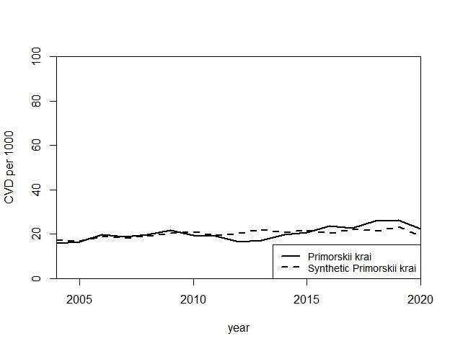
4А

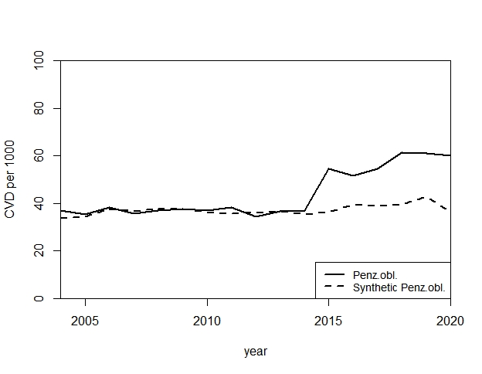
4В
Fig.4 Placebo tests with a random selection of the region (4 A - Primorsky Krai) and the time of intervention (4 B - 2011)
From the above placebo tests, it can be argued that the estimates obtained related to the evaluation of the efficiency of the functioning of the federal center for the profile "cardiovascular surgery" in the Penza region are reliable. In Figure 4A, the Primorsky Territory was modeled. The trends of the real region and its synthetics coincide throughout the entire period of the implementation of the National Project "Health" 2006-2010. Figure 4B shows synthetics for the Penza region, however, the year of operation of the center is 2011. This placebo test, once again, clearly confirms the results obtained, namely the inefficiency of the functioning of the center in the Penza region.

Conclusion
The functioning of federal centers on the profile of "cardiovascular surgery" had contradictory results, therefore, an assessment of its efficiency was carried out on the example of the Penza region. From the results obtained with the help of a synthetic control method, it can be concluded that this center is ineffective, since, perhaps, in its absence, the situation in the region might not have changed. Also, the possible impact on such dynamics of morbidity was also influenced by the shortage of qualified specialists, which was mentioned in the report on the activities of the Ministry of Health.

