SHOCK-DEPENDENT EXCHANGE RATE PASS-THROUGH:
AN EMPIRICAL ESTIMATE FOR RUSSIA BASED ON THE SVAR MODEL
A.V. Eliseev¹
¹ Bank of Russia (Volgo-Vyatka Main Branch), HSE University (Nizhny Novgorod)
i@alysee.ru
Introduction
Empirical estimates of the exchange rate pass-through to prices in Russia are usually based on studying the response of inflation to an unexpected change in the exchange rate, regardless of the structural shock that occurred: see, for example, studies by Dobrynskaya (2007), Ponomarev et al. (2014), Kartaeva and Yakimova (2018), Andreev (2019), and Zhurakovsky et al. (2021). However, as shown by Corsetti et al. (2007) and Forbes et al. (2018), the properties of the pass-through effect differ depending on what economic forces caused the unexpected change in the exchange rate. Developing this direction in relation to the Russian economy, Khotulev (2020), based on the DSGE model, also showed that in the case of various structural shocks, the magnitude of the exchange rate pass-through to prices and its time profile differ. For this reason, in order to correctly assess the effect of exchange rate pass-through into prices, it is important to understand what kind of structural shocks occur at a particular point in time.
Thus, the purpose of this study is to assess the size and time profile of the exchange rate pass-through to prices in Russia as a result of various structural shocks. Following Khotulev (2020), we obtain estimates of the exchange rate pass-through to prices depending on various structural shocks. At the same time, the novelty and contribution of our study lies in the fact that we solve the set goal not on the basis of a fully specified general equilibrium model, but using structural shocks identified on the basis of estimating the parameters of the reduced form of vector autoregression using historical data on the dynamics of the main macro variables of the Russian economy.
The relevance of our study is due to the fact that, starting from 2022, short-term fluctuations in the exchange rate in Russia may be due to shocks that previously did not so seriously determine the movement of the exchange rate. Since the transition to an inflation-targeting regime in 2014-2015, short-term fluctuations in the exchange rate in Russia have mainly been attributed to shocks in the external risk premium (Novak and Shulgin, 2020). This means that in recent years the reaction of inflation to an unexpected exchange rate shock has mainly characterized the pass-through effect of the external risk premium resulting from the structural shock. Since 2022, under the conditions of capital controls, real flows of benefits and the resultant state of the trade balance, rather than changes in the country risk premium, have become decisive for exchange rate fluctuations.
Methodology
For the purposes of this study, we have compiled a vector autoregression model of five variables: the current account (CA), changes in the nominal effective exchange rate (NEER), the interbank % rate (RUONIA), changes in the output of the basic sectors of the Russian economy (Output), and consumer inflation (CPI). Having estimated the parameters of the reduced form, using the method of Rubio-Ramirez et al. (2010) we have identified the following structural shocks: trade balance shock, external risk premium shock, monetary shock, demand shock, and supply shock. For the exact identification of the parameters of the structural form, a short-term matrix of sign constraints of the following type was used. Where possible, we have tried not to impose restrictions on the response of variables that are of interest to us in terms of properties of the exchange rate pass-through (NEER and CPI):
 | Trade balance Shock | External risk-premium shock | Monetary shock | Demand shock | Supply shock
CA | +
NEER |  | +
RUONIA |  |  | +
Output | + | + |  | + | -
CPI |  |  | - | + | +
According to the idea, a trade shock causes an improvement in the current account, which favors output. A shock in the external risk premium causes an unexpected weakening of the exchange rate, which positively affects output. A monetary shock leads to an unexpected rise in rates and lower inflation. A demand shock is identified through the unidirectional movement of output and inflation, while a supply shock is identified through their multidirectional dynamics.

Results
Analyzing the impulse response functions of variables to various structural shocks (Figure 1), in particular, we see the following. The shock of the trade balance causes the exchange rate to appreciate. This reduces consumer inflation, which in turn puts downward pressure on interest rates. A shock to the external risk premium, on the contrary, leads to a unidirectional movement of the exchange rate, inflation, output, and interest rates.
Let's move on to the analysis of the exchange rate pass-through. It can be seen (Figure 2) that the shock of the external risk premium does not exceed 0.25 and fully manifests itself in the first two quarters. On the contrary, the identified trade balance shock does not fully manifest itself in the first six months: the pass-through effect continues to increase in the next two quarters entirely due to the reaction of consumer prices with a stable exchange rate, but does not exceed 0.15 over a one-year horizon. The pass-through effect resulting from the action of a monetary shock is the largest among the two shocks listed above. In general, the results obtained are consistent with the assessments of Khotulev (2020) based on the DSGE model for the Russian economy.
Thus, the action of the trade balance shock leads to the smallest pass-through of the exchange rate into prices (manifestation of the asymmetry of the pass-through effect), but its effect may not be limited to two quarters.
Figure 1. Impulse response functions of variables to various structural shocks.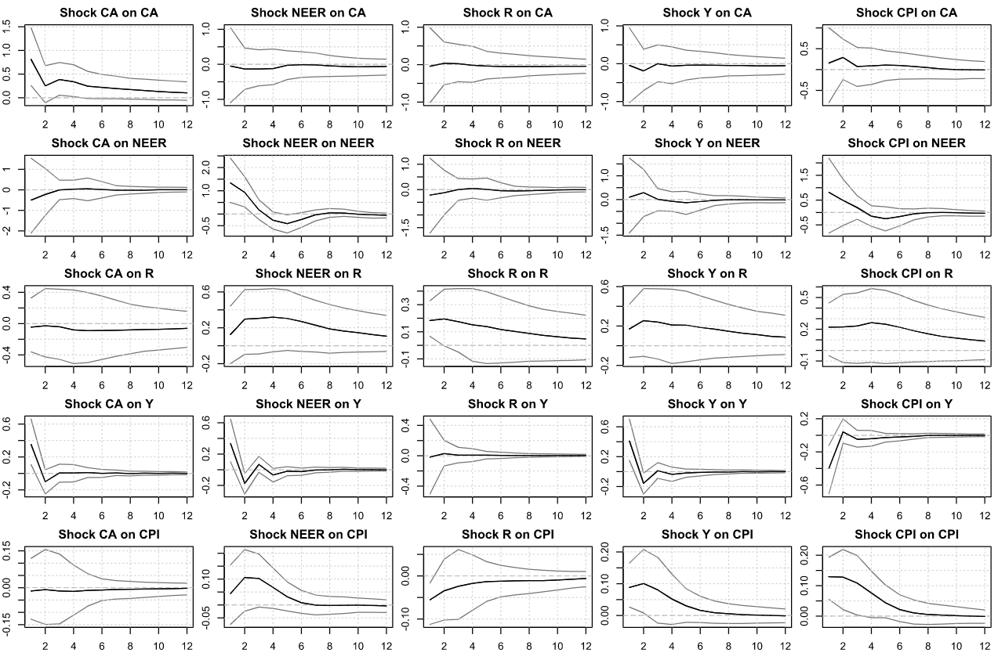
Source: author's calculations.

Figure 2. Exchange rate pass-through to prices depending on some structural shocks.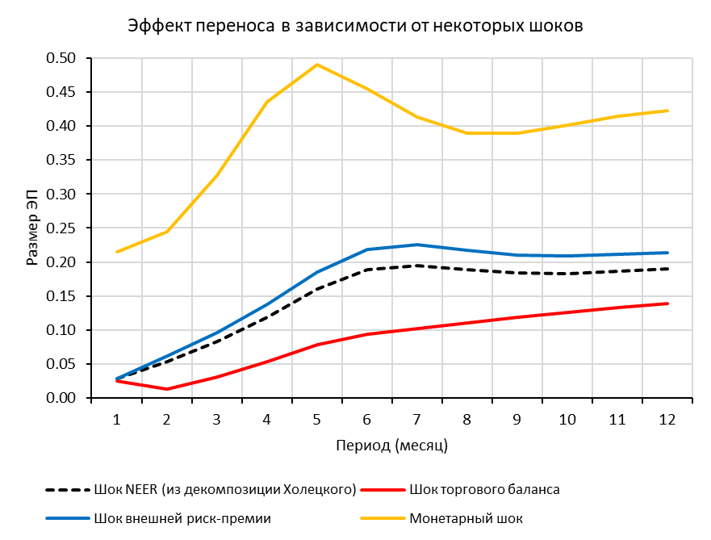
Source: author's calculations.

Disclaimer
The views expressed in this paper are solely those of the authors and do not necessarily reflect the official position of the Bank of Russia. The Bank of Russia assumes no responsibility for the contents of the paper.

References
- Corsetti, G., Dedola, L., Leduc, S., 2007. Optimal Monetary Policy and the Sources of Local-Currency Price Stability, pp. 319–367. University of Chicago Press.
- Forbes, K., Hjortsoe, I., Nenova, T., 2018. The shocks matter: Improving our estimates of exchange rate pass-through. Journal of International Economics 114, 255 – 275.
- Rubio-Ramírez, J. F., Waggoner, D. F., Zha, T., 2010. Structural Vector Autoregressions: Theory of Identification and Algorithms for Inference. The Review of Economic Studies, 77(2), pp. 665–696.
- Андреев, А. В., 2019. Исследование асимметрии и нелинейности переноса динамики обменного курса в инфляцию. Серия докладов об экономических исследованиях Банка России [in Russian].
- Добрынская, В. В., 2007. Эффект переноса и монетарная политика в России: что изменилось после кризиса 1998 г.? Экономический журнал ВШЭ 11(2), 213–233 [in Russian].
- Жураковский, В., Новопашина, А., Тарантаев, А., 2021. Региональная разнородность эффекта переноса валютного курса на инфляцию. Серия докладов об экономических исследованиях Банка России [in Russian].
- Картаев, Ф. С., Якимова, Ю. И., 2018. Влияние инфляционного таргетирования на эффект переноса валютного курса. Вопросы экономики (11), 51–65 [in Russian].
- Новак, А. Е., Шульгин, А. Г., 2020. Денежно-кредитная политика в экономике с региональной неоднородностью: подходы на основе агрегированной и региональной информации. Серия докладов об экономических исследованиях Банка России [in Russian].
- Пономарев, Ю. Ю., Трунин, П. В., Улюкаев, А. В., 2014. Эффект переноса динамики обменного курса на цены в России. Вопросы экономики (3), 21–35 [in Russian].
- Хотулев, И., 2020. Зависимость эффекта переноса валютного курса в России от экономических шоков. Аналитическая записка, Банк России [in Russian].

The coefficients of the model were estimated by the Bayesian method. For estimation, we used monthly series from 2014 to 2019 inclusive. We ignored data for 2020-2022. due to problems with the identification of shocks in the face of increasing their volatility and the corresponding impact on the dynamic characteristics of variables. Unlike Forbes et al. (2018), we ignored export and import prices due to their lack of data starting from 2022 in the conditions of the “closure” of foreign trade statistics, and also due to the absence of monthly frequency variables. When evaluating the parameters, we used a specification with 3 lags, selected based on the values of the information criteria.
“+” means the depreciation of the exchange rate, and “-” means its appreciation.
For the exact identification, it is necessary to impose 5*(5-1)/2=10 restrictions on the covariance matrix of VAR residuals of the reduced form.
First of all, it concerns the trade balance shock.
We estimate the pass-through effect to prices as the ratio between the cumulative CPI reaction and the cumulative exchange rate reaction for each of the identified structural shocks.

