Yu.A. Polunin, IPU RAS
A.Yu. Yudanov, Financial University
Annotation
Firm growth model as a nonlinear mapping (impact of limitation and backstory)
One of the central problems of the theory of the growth of a firm - the main subject of a market economy - is the variety of trajectories along which companies develop. “The growth process is different for different firms” [Mc Kelvie, Wiklund, 2010, p. 271]. Probably, in many respects for this reason, the concept of the life cycle of a firm, being intellectually extremely attractive (description of typical stages in the history of a firm from birth to death), has not been able to take place as a generally accepted theory for more than half a century. Moreover, it is unlikely that this is simply a matter of the difficulty faced by a particular group of theories. Rather, it is a manifestation of the lack of an approach in science that would explain different possible options for the development of a firm from a general point of view.
Meanwhile, nonlinear mappings make it possible to describe fundamentally different ways of a firm's growth that is uniform in terms of the structure of the mapping itself. The starting point can be an economically meaningful idea of ​​the firm as an actor seeking (a) to occupy the market niche available to it and (b) to make efforts to expand this niche. The process of occupying a niche - item (a) - is actively modeled in biology, including with the help of Verhulst's mappings [Verhulst, 1845]. Item (b) reflects the economic specifics, since firms, unlike animals and plants, are able to actively influence the size of a niche, both in the direction of expansion (with the right actions) and downward (with the wrong behavior).
Our proposed mapping, reflecting this understanding of the growth of a firm, is:
$$X_{n+1}=X_{n}+ X_{n}Q\left(R- X_{n}+ γX_{n-1}\right), (1)$$
The revenue value at the next time step ($X_{n+1}$) is presented in the form of two terms: first, the revenue achieved at the previous step ($X_{n}$) and, secondly, the new part of the niche that can be occupied at the current time step (master part of the free niche). The second term is presented as the product of the intensity factor of the process of developing a market niche $Q$ by the current size of the company's revenue $X_{n}$ and by a variable reflecting the dynamics of the free part of the market niche (expression in parentheses).
The larger the free niche, the less restrictions on growth. The free part of the niche depends on the initial size of the market niche$R$, on the share already occupied by the company, equal to the revenue of the current period $X_{n}$, and on the term reflecting the influence of the history on the size of the niche $γX_{n-1}$.
The influence of history can be summarized as the amount of revenue generated at the firm by the time preceding the current moment ($X_{n-1}$), multiplied by the coefficient $γ$, reflecting the general patterns of this influence.
The dynamics of Verhulst processes for various parameters of the model without the influence of prehistory ($γ$ = 0) has been well studied. At values ​​of the normalized intensity $Q$ < 2, the process looks like an S-shaped curve, which comes to the limiting state - a point attractor equal to unity (i.e., to the normalized size of the niche $R$).
Picture 1. Dynamics of the firm's revenue in established markets ($X_{0}$ = 0.001).
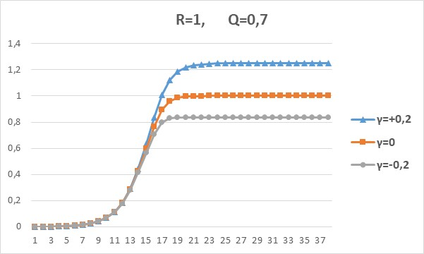
Even this simple description (in picture 1, the case $γ$ = 0) is well suited for the vast majority of small firms, which, as is known [Global Entrepreneurship Monitor, 2017/18], practically do not grow after occupying the initial niche. More broadly, a similar dynamic applies to almost all firms operating in mature markets, except for the few innovators who revolutionize them.
Consideration of the influence of prehistory introduces a significant clarification. If a firm actively improved its product, improved its promotion, etc., then this influence is positive (curve $γ$ = 0.2 in picture 1) and a plateau is reached when values ​​exceed the initial limit. The firm has grown its original niche. Otherwise (insufficiently high quality, mistakes in promotion, etc. - case $γ$ = -0.2) the attractor is reached due to the negative influence of the prehistory at a level less than one, i.e. an objectively accessible niche cannot be filled.
Note that far from the filling level of the niche ($R$ = 1), all three curves coincide, and only when approaching it does divergence occur. Thus, the model conveys the well-known fact to economists that the importance of non-price factors of competition (generalized here as the role of prehistory) increases with market saturation.
Picture 2. Dynamics of revenue of firms that have failed to master a niche ($X_{0}$= 0.001).
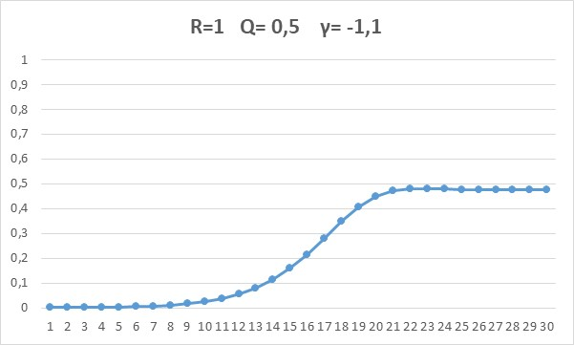
Picture 2 reflects the situation of a more powerful negative influence of prehistory. Growth stops long before reaching the initial limit ($R$ = 1). In the real world, this is a typical situation for innovative firms, most of which, especially in Russia, fail to reach their target sales volumes. According to the apt observation of D. Medovnikov (HSE NRU HSE), going out of the gates of technoparks and business incubators, despite their initial successes, they never become truly big business, freezing in the eternal "puberty". In fact, we are talking about a fundamental discrepancy between market expectations and the real qualities of the manufactured product.
Picture 3. Quasi-unlimited growth of the firm's revenue ($X_{0}$ = 0.01)
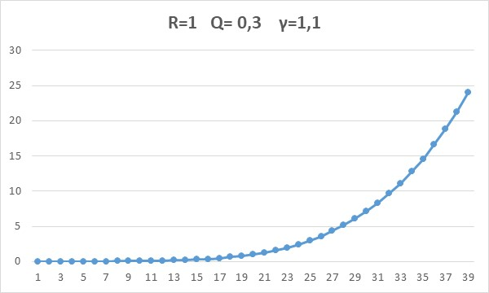
Picture 3 reflects quasi-unlimited revenue growth with a strong positive influence of the background: by step 39, the initial value of the limit was exceeded not by percent, but by 24 times. There are indeed objects in the economy that have similar properties - the so-called fast-growing companies or gazelles [for reviews, see Benedetti et al., 2021; Arti et al., 2019]. For example, the averaged data for 11 generations of Russian gazelles for 1999-2013. give a 30-fold increase in revenue in 5 years. The extremely positive contribution of prehistory to their development is associated with the introduction to the market of a highly demanded, but previously absent product.
However, even this growth is not sustainable for all parameters. Real gazelles sometimes go bankrupt (mainly due to weak cost control), and often lose their dynamism dramatically. Model with parameters Fig. 3 for the fortieth steps goes to minus infinity.
*
This review of nonlinear mappings, taking into account the existence of limitations and the influence of prehistory, is aimed solely at demonstrating their potential as tools for modeling the growth of a firm. The main advantage is seen in universality, in the applicability of a uniform approach to completely different types of firms. To date, the first results of its use have been obtained in the analysis of socio-economic processes and, specifically, the dynamics of Russian firms [Polunin, 2019; Polunin, Yudanov, 2020].

