DERIVATIVES MARGIN INFLUENCE ON TRADING VOLUME
A.I. Potapov¹
¹ Higher School of Economics, Moscow, Russia, aipotapov@hse.ru
The main goal of the research is to estimate the derivatives optimal margin on the Moscow Exchange, considering its impact on the trading activity. To do this, the optimization problem of maximizing the profit of the exchange is solved, where margin acts as a variable. Then, the estimated margin volume is checked for compliance with international requirements and the impact of margin on market liquidity and exchange profit is assessed.

Assigning margin is a dual optimization problem
The global financial crisis of 2007-2009 triggered a lot of defaults on the derivatives market. International acts [Regulation (EU) No 648/2012, Dodd-Frank Wall Street Reform and Consumer Protection Act] were adopted to prevent such events in future and minimize risks. The documents regulate the obligation of the exchange to create a margin system for derivatives. This system implies a set of standardized requirements for the opening and maintenance of the client account, the balance of which changes through the position profit or loss. The system operation allows to reduce the burden on participants and avoid losses in case of counterparty default (in this case the exchange receives all collateral of the defaulter and fulfills default obligations).
On the one hand, the exchange must maintain a system of margin under international requirements for reliability [CPSS - IOSCO, 2012]. On the other hand, the exchange increases the costs of trading for participants, harming liquidity [Brunnermeier, Pedersen, 2009]. Thus, the exchange’s profit can be represented as:
$$\begin{aligned}{Profit}_{t}^{i}=\sum_{j=1}^{k}{\left(min\left({TМ}_{t-1;k}^{i}+{dTV}_{t;k}^{i};0\right)*Q\left(default_{k}\right)+{TA}_{t;k}^{i}*fees_{t}\right) }\#(1)\end{aligned}$$
$$\begin{aligned}∀ i,k,t: P\left({dTV}_{t;k}^{i}<{-TM}_{t-1;k}^{i}\right)≤0.01 \#\left(2\right)\end{aligned}$$
$t$ – observation,
$i$ – underlying asset,
$j$ – market participant,
$TM$ – current margin,
$dTV$ – changes in value of portfolio,
$TA$ – daily trading volume,
$fees$ – commission on trading,
$Q(default)$ – participant default probability.
The Exchange as a commercial organization is interested in setting the minimum acceptable level of margin (covering potential losses with a probability of 99%) to increase liquidity and its own profit. Thus, the exchange when assigning the margin should maximize its own profit (1) under given constraints (2).

Margin is overestimated in case of one instrument portfolio
An effective margin system, as a risk assessment system, is characterized by robustness and coherence. A coherent risk measure has the following properties: invariance to a constant, subadditivity, positive homogeneity, and monotonicity [Artzner et al, 1999]. Then and only then it can be used as an accurate estimate, reflecting the actual existing risk at the given level of confidence.
In practice, the property of subadditivity is not fulfilled because diversification and hedging within client’s portfolio are not considered by margin systems [Emmer et al., 2015]. So some overestimation of the margin level occurs.
To confirm the fact of overestimation a GARCH model was used to predict the correlated risk-factors of margin system (returns and changes of implied volatility).
By comparing the margin offered by the suggested stochastic model and the MOEX margin, it can be concluded that for call/put options "in the money"/"on the money" and long/short futures the real margin value is significantly overestimated. Meanwhile both models meet international requirements.

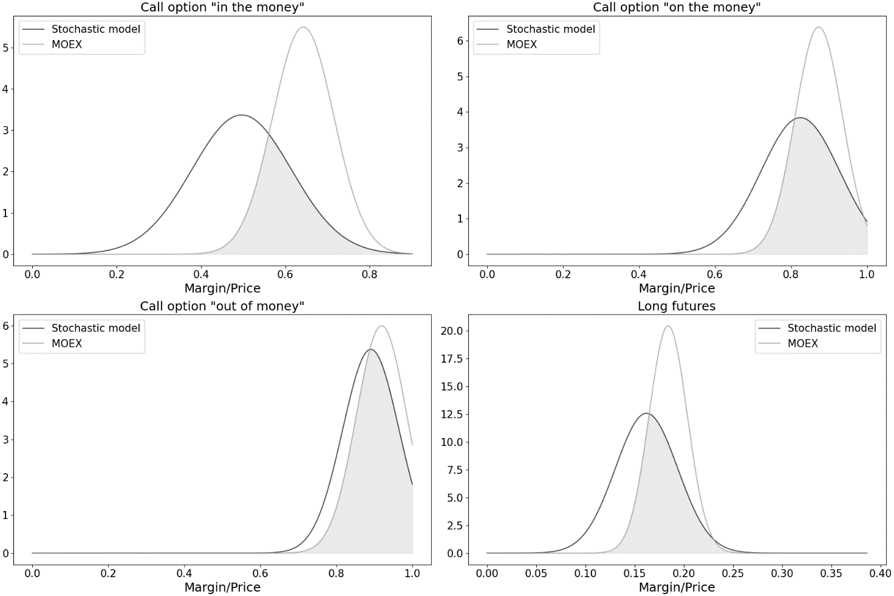
Graph 1. Comparison of stochastic model margin estimates and MOEX margin on futures and options on the 25 stocks and indexes in the period from 01.2017 to 12.2020.

Margin size negatively affects trading volume
The existence of a margin system is a positive factor: ensuring market transparency, increasing its efficiency and liquidity [Acharya, Bisin, 2014]. At the same time, assigning an incorrect margin can reduce the positive effect: too high margin increases the probability of participants default and decreases market liquidity [Gerano, 2016]. Excessive margin levels also negatively affect the number of market participants, volatility, and profits. These effects are particularly evident when the margin significantly exceeds the risk assessment of the participants themselves (xVA on the OTC market) [Daskalaki, Skiadopoulos, 2016].
The MOEX data is separated by type of position (long or short) and type of client (individuals or corporates). Evaluation of the impact is conducted for each type separately. The data contain autocorrelation and strong interconnection, so the Vector Autoregression model was proposed:
$$\begin{aligned}\left\{\begin{aligned}\ln\left(\frac{TA_{t}}{TA_{t-1}}\right)=a_{1,0}+β_{1,1}*\ln\left(\frac{{TM}_{t}}{{TM}_{t-1}}\right)+β_{1,2}*\ln\left(\frac{PV_{t-1}}{PV_{t-2}}\right)+β_{1,3}*\ln\left(\frac{{rf}_{t-1}}{{rf}_{t-2}}\right) \\ +β_{1,4}*return_{t-1}{+β_{1,5}*\ln\left(\frac{{OI}_{t-1}}{{OI}_{t-2}}\right)+β_{1,6}*\ln\left(\frac{{TA}_{t-1}}{{TA}_{t-2}}\right)}+ϵ_{1,t} \\ \ln\left(\frac{TM_{t}}{{TM}_{t-1}}\right)=a_{2,0}+β_{2,1}*ln\left(\frac{{TA}_{t}}{{TA}_{t-1}}\right){+β_{2,2}*\ln\left(\frac{PV_{t-1}}{PV_{t-2}}\right)+β_{2,3}*\ln\left(\frac{{rf}_{t-1}}{{rf}_{t-2}}\right)} \\ +β_{2,4}*return_{t-1}{+β_{2,5}*\ln\left(\frac{{OI}_{t-1}}{{OI}_{t-2}}\right)+β_{2,6}*\ln\left(\frac{{TM}_{t-1}}{{TM}_{t-2}}\right)}+ϵ_{2,t}\end{aligned}\right.\#\left(3\right)\end{aligned}$$
$TM$ – current margin,
$TA$ – daily trading volume,
$PV$ – return volatility,
$rf$ – risk-free rate till the maturity,
$Return$ – logarithmic return,
$OI$ – open interest,
$ϵ$ – model error.
The results show that, firstly, margin increases negatively affect trading volume for all positions and clients at any significance level, and secondly, it may lead to increased probability of CCP default followed by further growth of margin.

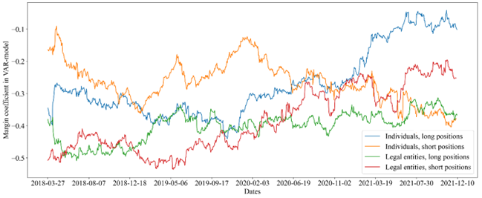
Graph 2. Estimates margin’s influence on trading volumes for different types of clients

References
- Regulation (EU) No 648/2012 of the European Parliament and of the Council of 4 July 2012 on OTC derivatives, central counterparties, and trade repositories.
- Dodd-Frank Wall Street Reform and Consumer Protection Act. 12 USC 5301 note. Public Law 111–203, 111th Congress.
- Bank for International Settlements and International Organization of Securities Commissions. (2012). Committee on Payment and Settlement Systems. Technical Committee of the International Organization of Securities Commissions. Principles for financial market infrastructures.
- M. Brunnermeier, L. Pedersen. «Market liquidity and funding liquidity». The Review of Financial Studies, 2009, Vol.22, pp.2201–2238.
- P. Artzner, F. Delbaen, J.-M. Eber, D. Heath. «Coherent Measures of Risk». Mathematical Finance, 1999, Vol.9, pp.203–228.
- S. Emmer, M. Kratz, D. Tasche. «What Is the Best Risk Measure in Practice? A Comparison of Standard Measures». Journal of Risk, 2015, Vol.18, pp.31–60.
- V. Acharya, A. Bisin. «Counterparty risk externality: Centralized versus over-the-counter markets». Journal of Economic Theory, 2014, Vol.149, pp.153–182.
- A. D. Gerano. «Systematic multi-period stress scenarios with an application to CCP risk management». Journal of Banking and Finance, 2016, Vol.67, pp.119–134.
- C. Daskalaki, G. Skiadopoulos. «The effect of margin changes on commodity futures». Journal of Financial Services Research, 2016, Vol.22, pp.129-152.

