Macroeconomic Uncertainty Indicators for Russia
I.Prilepskiy

Over the last decade, there has been a spike in interest in economic uncertainty and its growth effects, largely due to the experience of 2008-2009, when uncertainty played a major role in the propagation of the global financial crisis. Defined as an unpredictable component of volatility of economic shocks, it can negatively impact growth through avoidance of investment in the presence of fixed costs (a ‘real options’ effect), increase in precautionary saving, or tightening of financial conditions.
Common approaches to constructing uncertainty indicators include:
- utilizing financial variables, such as the VIX index reflecting investors’ expectations of future 30-day US stock market volatility and calculated based on prices of options on S&P 500 Index;
- calculating economic policy uncertainty based on newspaper articles; estimating uncertainty related to geopolitical risks represents a related approach;
- direct assessment of uncertainty as ‘unforecastability’ of economic dynamics, which can be performed both non-parametrically (based on surveys) and through analyzing the variance of forecast errors constructed based on parametric models (Jurado et al., 2015)
Uncertainty-related topics are especially relevant for Russia. First, all major oil-producing countries face high volatility of external conditions. Second, in the recent years Russia has been dealing with a new source of uncertainty due to sanctions. However, the number of studies on this topic remains low, and those studies mainly tackle economic policy uncertainty (Fedorova et al., 2019; Naidenova, Leonteva, 2020). The aim of this study is to construct an indicator of macroeconomic uncertainty based on (Jurado et al., 2015) methodology, compare it with alternative uncertainty indicators, and analyze its impact on macroeconomic variables.
This approach involves defining macroeconomic uncertainty as a weighted sum of conditional volatilities of forecast errors (with horizon h) for a set of economic and financial variables:
$U_{t}(h)=\sum_{j}{w_{j}U_{t}^{\left(j\right)}\left(h\right), U_{t}^{\left(j\right)}\left(h\right)=\sqrt{E\left[{\left(y_{t+h}^{(j)}-\hat{y_{t+h}^{\left(j\right)}}|t\right)}^{2}|t\right]} }$. (1)

Monthly data for N=39 variables covering 2004:01-2020:02 (i.e. up to COVID-19 pandemic) are utilized. The set includes indicators of real activity (e.g. GDP, industrial production, freight turnover), personal income, employment, retail markets, credit and monetary aggregates, exchange rate, external trade, CPI and producer prices, interest rates and financial market indices. All variables are properly differenced to ensure stationarity and normalized to zero mean and unit standard error. Designating $Y_{t}={\left\{y_{t}^{(j)}\right\}}_{j=1}^{N}$, factor-augmented forecasting model may be written as

$Y_{t}=Λ^{F}F_{t}+u_{t}; Y_{t}^{2}=Λ^{W}W_{t}+v_{t};$ (2)
$y_{t+h}^{(j)}=ρ\left(L\right)y_{t}^{(j)}+β\left(L\right)F_{t}+γ\left(L\right)F_{1,t}^{2}+δ\left(L\right)W_{t}+ζ\left(L\right)G_{t}+e_{t+h}^{(j)}$. (3)
Here, F_{t} and W_{t} are the vectors of common factors behind the dynamics of individual variables, estimated by principle component analysis; G_{t} is the vector of exogenous variables (oil prices, external financial conditions, sanctions’ intensity index from (Omelchenko, Khrustalev, 2018)). To account for possible persistence of volatility, residuals $e_{t+h}^{(j)}$ are assumed to follow the process $e_{t+h}^{(j)}=σ_{j,t}^{y}ε_{j,t}^{y}$, $ε_{j,t}^{y}\sim i.i.d N\left(0,1\right), lnσ_{j,t}^{y}=α_{j}^{y}+β_{j}^{y}lnσ_{j,t-1}^{y}+τ_{j}^{y}η_{j,t}, η_{j,t}\sim i.i.d N\left(0,1\right)$. In addition, F_{t} and W_{t} are assumed to also follow autoregressive processes with the similar structure of residuals. Weights $w_{j}$ in (1) are taken to be equal.
Estimation results for h=1, 3, 12 months (u1, u3, u12) are reported in Figure 1 together with RVI, a Russian equivalent of VIX calculated by the Moscow Exchange. Spikes corresponding to the acute phase of the 2008-2009 crisis and the sharp fall of oil prices in late 2014 are clearly visible. Table 1 reports the persistence of constructed indicators, as compared to alternative indicators:
- Russia’s economic policy uncertainty (PU; Baker et al., 2016);
- Russia-related geopolitical risk index (GPR; Caldara, Iacovello, 2021);
- index of uncertainty of Western sanctions imposed on Russia (SU; calculated based on the frequency of such restrictions being mentioned in Vedomosti and Kommersant newspapers, starting in January 2014);
- index of expected 30-day oil price volatility provided by Chicago Board Options Exchange (OILV).
Furthermore, coefficients of pairwise correlation with estimated indicators and next-month GDP dynamics are presented. Estimated indicators u are highly persistent and clearly countercyclical. Correlations with alternative indicators are positive and significant, except PU.

Table 1. Comparison of uncertainty indicators
 | u1 | u3 | u12 | RVI | PU | GPR | SU | OILV
AR(1) coefficient | 0,94 | 0,91 | 0,81 | 0,79 | 0,19 | 0,41 | 0,69 | 0,85
corr(*, u1) | 1 | 0,98 | 0,89 | 0,87 | 0,02 | 0,29 | 0,34 | 0,49
corr(*, u3) |  | 1 | 0,96 | 0,90 | 0,06 | 0,31 | 0,38 | 0,48
corr(*, u12) |  |  | 1 | 0,88 | 0,11 | 0,31 | 0,38 | 0,49
corr(*, GDP₊₁) | -0,33 | -0,27 | -0,17 | -0,25 | 0,27 | 0,07 | 0,18 | -0,51

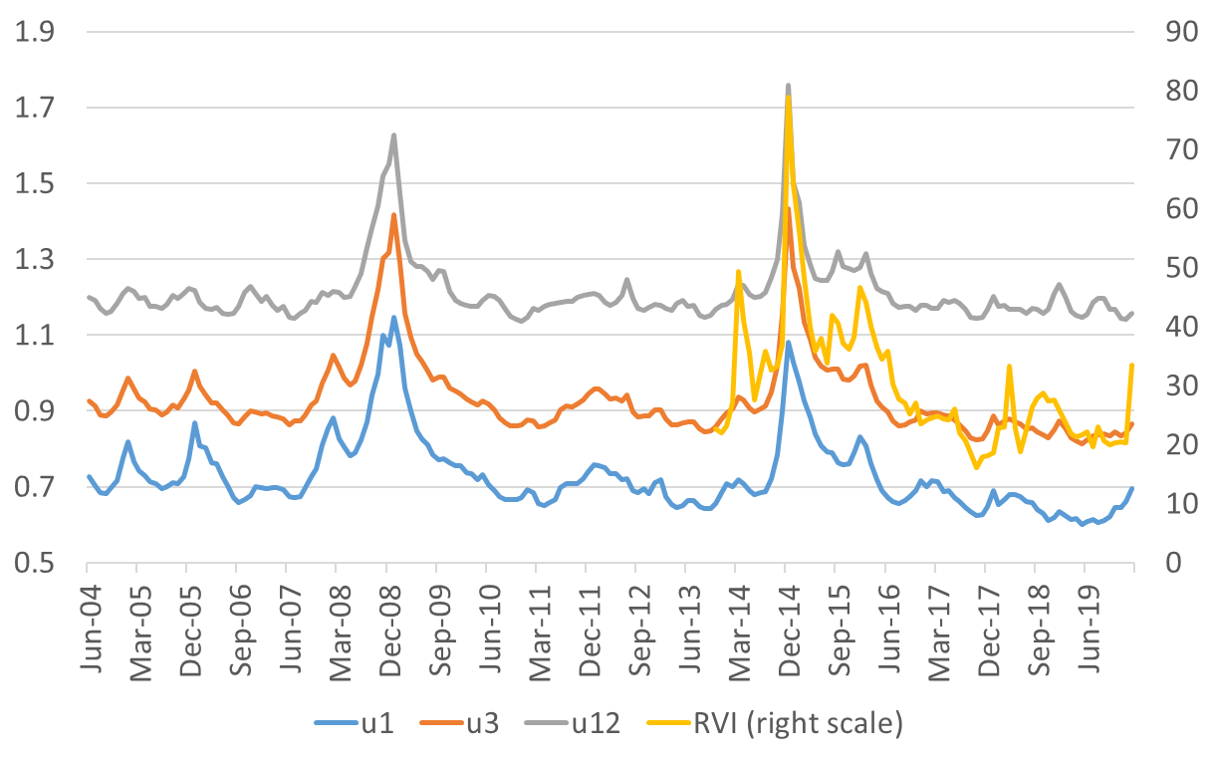
Figure 1. Uncertainty dynamics (sources: Moscow Exchange; author’s calculations).

To assess the impact of uncertainty on other macroeconomic variables, stationary VAR model was estimated on monthly data, with GDP, inflation and short-term government bond yield as endogenous variables and oil prices and VIX as exogenous ones. When constructing impulse responses, uncertainty indicators were ordered last in the Cholesky decomposition. Examples of responses to uncertainty shocks (equal to one standard deviation of identified shocks for d(u3)) are reported in Figure 2. Significant impacts on inflation and yield are visible, along with a significant impact on GDP starting six months after the shock. Note that shocks of alternative uncertainty measures do not result in significant responses.
To conclude, estimating uncertainty based on forecast errors of factor-augmented models could be promising; in particular, analysis of instruments for reducing uncertainty could be valuable for enhancing efficiency of countercyclical policies.
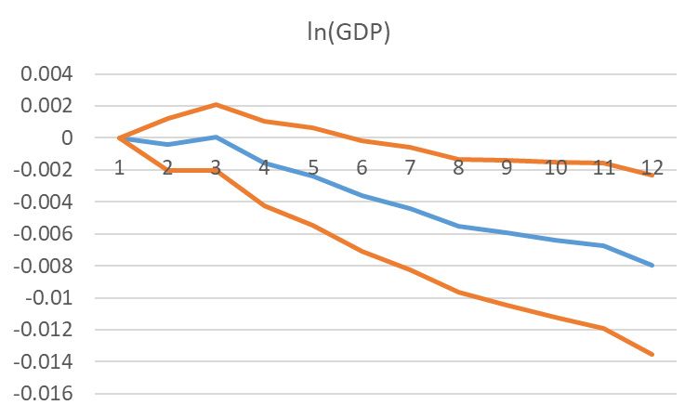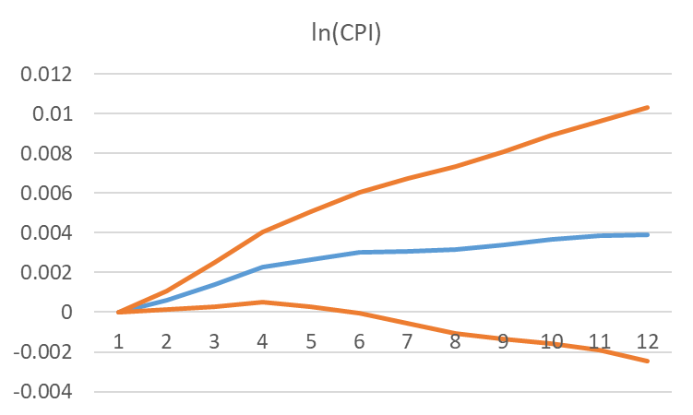
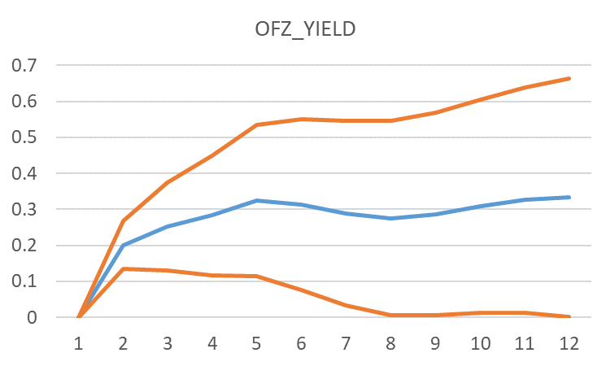
Figure 2. Accumulated responses to u3 shocks and 90% confidence intervals (source: author’s calculations)

References
Baker S.R., Bloom N., Davis S.J. (2016). Measuring economic policy uncertainty. Quarterly Journal of Economics, 131(4):1593-1636.
Caldara D., Iacoviello M. (2021). Measuring Geopolitical Risk. Working paper, Board of Governors of the Federal Reserve.
Fedorova E.A., Musienko S.O., Fedorov F.Yu. (2019). Development of Russian Political Uncertainty Index (RPUI): Textual Analysis. Economics of Contemporary Russia. No. 2, pp. 52-64. (In Russian)
Jurado K., Ludvigson S.C., Ng S. (2015). Measuring uncertainty. The American Economic Review, 105:1117-1216.
Naidenova Yu.N., Leonteva V.V. (2020). Economic policy uncertainty and investment of Russian companies. Voprosy Ekonomiki. No. 2, pp. 141-159. (In Russian)
Omelchenko A., Khrustalev E. (2018). The Model of Sanction Intensity Index: Evidence from Russia. National Interests: Priorities and Security, 14(1), 62–77 (in Russian).

PhD (Physics and Mathematics); Head of Global Economy Division, Economic Expert Group, Moscow; Senior researcher, Centre for Budget Analysis and Forecasting, Financial Research Institute, Moscow
Period from January 2014 is used for comparability

