Modeling relationships in the digital economy based on the knowledge production function
Bagautdinova Nailya Gumerovna, Kadochnikova Ekaterina Ivanovna
Kazan Federal University
In the fourth industrial revolution, human capital, as a stock of produced knowledge, is becoming a key factor in sustainable economic growth, human-centered technologies are a major direction in leading management practices, and the digital divide is becoming a new factor of economic and social inequality in Russia. In 2020, less than 10% of manufacturing enterprises planned to introduce digital technologies, and 60% are in finance, transport, energy and healthcare, 69 constituent entities of the Russian Federation account for a fifth of all patent claims for inventions in digital technologies. The production function of knowledge appears to be an adequate approach for modeling connections in the digital economy. An important consequence of the relationship between the diffusion of technology as a product of knowledge and sustainable growth is the convergence of its rates. Endogenous growth theory and empirical evidence recognize that space is critical to knowledge diffusion and innovation. Therefore, research questions are of interest: Is there a long-term convergence of knowledge production in the regions? What is the impact of human capital and digitalization on knowledge production, taking into account their interregional interaction? Research hypothesis: the impact of human capital and digitalization on knowledge production is not the same, both directly (within regions) and indirectly (in neighboring regions).
Model. The production function of knowledge has been modified with temporal and spatial lags. Dependent variable are the average growth rate of issued patents for inventions and utility models per 10 thousand population. Independent variables are the number of research and development personnel per 10 thousand population; internal costs of R&D per capita, thousand rubles; use of the Internet in organizations, %; expenditures for the introduction and use of digital technologies per capita, thousand rubles; expenditures for technological innovation per capita, thousand rubles (as a proxy of technology development); fertility rate, % (as a proxy of the social environment).
In the R software environment, the Moran and Geary indices were estimated and models of conditional β-convergence were built on panel data by the SAR, SDM, SEM types:
where i = 1, ... 79 is the number of the region, [t₀ + T] is the convergence period from 2014 to 2019, y_{i,t0} is the number of issued patents in 2014, β is the convergence parameter, γ_{k} - estimated parameters for independent variables; W_{ij} is inverse distance weighting, ρ, λ is a spatial coefficients, ε_{i,t0+T} is a random error with a normal distribution.
Results. Moran's charts from 2012 to 2019 showed the concentration of most regions in the LL quadrant. The Moran and Geary Global Indices found that strong regions contribute to the growth of human capital and the production of knowledge from their neighbors. As technological innovation is concentrated in strong regions with a high concentration of factors of production, this could predict a technological breakthrough thanks to the leading regions.
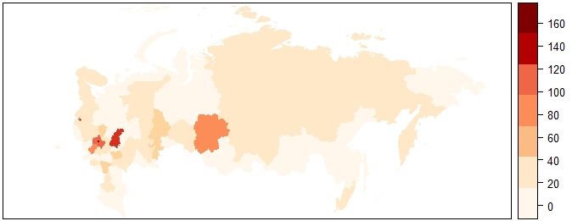
Fig. 1. Cartogram of the number of personnel engaged in R&D per 10 thousand population in 2019.
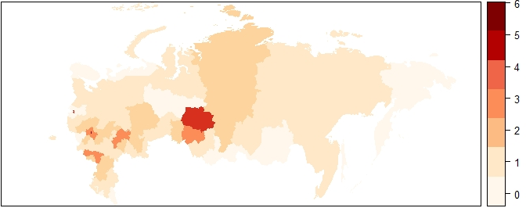
Fig. 2. Cartogram of the number of issued patents for inventions and utility models per 10 thousand population in 2019.
The found β-convergence indicates an increase in knowledge production in weak regions. As expected, the positive impact of human capital, internal costs of R&D per capita, expenditures for technological innovation per capita was confirmed. Positive significant spatial coefficients (p) and (λ) affirm the assumption of regional cooperation and the impact of shocks from neighboring regions on the growth of knowledge production in this region. Spatial interactions of the number of personnel engaged in R&D and the internal costs of R&D with the dependent variable were found.
Direct effects (effects within the region) affirmed the positive impact of human capital, internal costs of R&D and the cost of technological innovation on the knowledge production in the region. Significant indirect effects, i.e. the impacts of neighbors indicate the positive effect of internal costs of R&D. Significant direct and indirect effects of digitalization have not been identified. Perhaps this is due to the fact that the share of the ICT sector in Russia’s gross value added is less than 3% , a quarter of the adult population do not have digital skills, about 40% of our fellow citizens have only basic digital skills Overall, it's too early to talk about digital abundance .
Conclusions. The discovered β-convergence of the average growth rates of knowledge production and their spatial dependence under conditions when many regions have little human capital and patenting, can confirm the diffusion of technologies through their copying from the leading regions, which is cheaper than the invention of new ones. Regions that are technology followers attract external investment, gradually catch up with technology leaders and promote the convergence of knowledge production growth. However, the assumption about the significant impact of digitalization on the production of knowledge in the regions was not confirmed.
Research novelty. The novelty of the study lies in measuring the convergence of the average growth rates of knowledge production in the regions, taking into account spatial interactions. The results can be used by authorities and other institutions in managing the transformation of economic and social sectors through the introduction of digital technologies and platform solutions, in providing training in accordance with the goals of the National Project "Digital Economy".

Schwab K. The Fourth Industrial Revolution. - M .: Eksmo, 2016.
Digital technologies in the Russian economy. Ed. L.M. Hochberg. - M .: HSE University, 2021.p. 108
Digitalization for humans: “What we are doing now is comparable to the conquest of space.” ISSEK HSE University. URL: https://issek.hse.ru/news/463373122.html
Involving regions in the development of digital technologies. ISSEK HSE University. URL: https://issek.hse.ru/news/513322514.html
Griliches Z. Issues in assessing the contribution of research and development to productivity growth. The Bell Journal of Economics. 1979.Vol.10. P. 92–116. Pakes A., Griliches Z. Patents and R&D at the firm level: A first look. R&D, Patents, and Productivity. Chicago: University of Chicago Press. 1984. P. 55–72.
Barro R. Economic growth / R. J. Barro, H. Sala-i-Martin. –M .: Binom. Knowledge laboratory. 2014.
Krugman, P.. The role of geography in economic development. International Regional Science Review. 1999. Vol. 22 (2). P. 142–161. Fritsch M, Franke G. Innovation, regional knowledge spillovers and R&D cooperation. Research Policy. 2004. Vol. 33. P. 245–255.
Barro, R., Sala-i-Martin, X. Convergence. The Journal of Political Economy. 1992. Vol. 100 (2). P. 223–251. Rey S J., Montouri B.D. US Regional Income Convergence: A Spatial Econometric Perspective. Regional Studies, 1999. Vol. 33(2). P. 143 – 156.
Elhorst, J. Spatial Econometrics. From Cross-Sectional Data to Spatial Panels. Springer. 2014.
Bagautdinova N, Kadochnikova E., Technological innovations: Analysis of short-term spatial effects in regions by development of econometric model//Industrial Engineering and Management Systems. - 2020. - Vol.19, Is.4. - pp.888-895
Indicators of the digital economy: 2020: statistical collection. - M .: HSE University, 2020.
How Russians are settling in the new digital world. ISSEK HSE University. URL: https://issek.hse.ru/news/461512008.html
Bagautdinova N.G. On the question of the mechanisms of the "resource curse” in the digital economy. V International Economic Symposium. St. Petersburg, 2021. P. 164-170. Kadochnikova E. I., Bagautdinova N. G. The "Resource Curse" in the Digital Economy: an Econometric Assessment. The 68th North America Meetings of the Regional Science Association International, Denver, NARSC, 2021.

