XXIV Yasinskaya (April)
international scientific conference
on problems of economic and social development
Excess child and adolescent summer mortality: the effect of long school holidays?
Polina Kuznetsova (with Tatiana Maleva)
Institute for Social Analysis and Forecasting at RANEPA
E-mail: polina.kuznetsova29@gmail.com
Mortality in Russia has a pronounced seasonality: deaths occur more often in winter, at the peak of seasonal respiratory diseases. However, for certain age groups, this rule is violated and summer mortality in them is noticeably higher. This can be seen in the weekly data of the Human Mortality Database (Table 1). The seasonality coefficients, calculated as the ratio of the average monthly number of deaths in June-August and the average monthly number of deaths in 2019, reach a maximum at the age of 5-14 years and then decrease below unity after 45 years, which corresponds to the transition to the winter seasonality of mortality (Table 1)
Table 1. Mortality seasonality index by age, men and women, 2001-2020
 | Мужчины |  |  |  |  |  | Женщины
Год | 2000 | 2005 | 2009 | 2015 | 2019 | 2020 | 2000 | 2005 | 2009 | 2015 | 2019 | 2020
0-4 | 94 | 102 | 97 | 94 | 101 | 99 | 93 | 96 | 97 | 93 | 101 | 95
5-9 | 160 | 155 | 133 | 133 | 107 | 115 | 132 | 130 | 105 | 93 | 105 | 122
10-14 | 150 | 146 | 142 | 136 | 139 | 148 | 161 | 148 | 130 | 119 | 107 | 107
15-24 | 128 | 137 | 122 | 117 | 115 | 130 | 131 | 130 | 102 | 103 | 105 | 121
25-34 | 118 | 118 | 106 | 96 | 102 | 107 | 114 | 110 | 94 | 91 | 92 | 106
35-44 | 102 | 98 | 96 | 96 | 100 | 105 | 97 | 93 | 92 | 91 | 95 | 107
45-54 | 99 | 93 | 92 | 89 | 91 | 103 | 93 | 89 | 85 | 85 | 91 | 108
55-64 | 89 | 90 | 96 | 90 | 90 | 103 | 85 | 83 | 91 | 88 | 87 | 106
65-74 | 86 | 87 | 87 | 89 | 96 | 112 | 82 | 82 | 85 | 86 | 93 | 115
75-85 | 83 | 87 | 85 | 85 | 87 | 108 | 81 | 84 | 83 | 85 | 86 | 106
85 лет и старше | 72 | 81 | 86 | 86 | 85 | 109 | 74 | 79 | 84 | 83 | 84 | 104
Примечание. Вместо 2010 г., характеризовавшегося экстремальными погодными условиями в европейской части страны, был рассмотрен 2009 г. К данным пандемийного 2020 г. были добавлены данные за 2019 г.
Источник. Расчеты авторов на данных STMF HMD, см. https://www.mortality.org/
In the 2010s the general decrease in mortality contributed to a significant decrease in the seasonality of female mortality at the age of 10-14 years: from 143 in 2010 to 107 in 2019. At the same time, among men of this age group, a significant seasonality of mortality remains (see the marked values ​​in Table 1) . In our opinion, this may be one of the consequences of child neglect during long school holidays, from which boys, who are often more active and more prone to risky behavior, may suffer more (Weden and Zabin 1998; Chun and Mobley 2010; Knyazev et al 2004; Boriskin et al. 2018). It should be especially noted that a significant excess of the number of summer deaths over winter ones occurs against the background of a significant increase in mortality during the New Year holidays, which is concentrated, however, at older ages (Nemtsov and Fattakhov 2021).
Due to the relatively small number of deaths, as well as the lack of data, seasonality at younger ages in Russian data, to the best of our knowledge, has not yet been considered in detail. In this regard, the data of the Human Mortality Database are of great interest. They contain information on weekly mortality among various sex and age groups in several countries of the world, including Russia. The purpose of this study is to study in detail the seasonality of mortality at younger ages in Russia over the past twenty years and, if possible, test the hypothesis about the effect of the duration of school holidays on the range of seasonal fluctuations.
When analyzing seasonality, it is necessary to use correct estimates. In Table 1, we present estimates of seasonality based on a comparison of data from the initial time series of mortality without taking into account long-term changes in its dynamics (trend) and random fluctuations. In scientific practice, econometric methods are used to extract individual components from the original time series, such as trend, seasonality, and error, which makes it possible to more correctly assess seasonality and conduct intertemporal and intergroup comparisons (Asif et al. 2019; Rodionova and Kopnova 2019).
To assess seasonality, the Tramo-Seats method, originally developed for the Bank of Spain and widely used to detect seasonality in time series, was applied to the original mortality data in 5-year sex and age groups. The calculations were carried out using the JDemetra econometric package developed by Eurostat, see https://ec.europa.eu/eurostat/cros/content/software-jdemetra_en. Using the Tramo-Seats procedure, the initial series was decomposed into a trend, as well as seasonal and random (irregular) components. Seasonally adjusted was defined by us as the ratio of the observed mortality value to the trend value; in the literature, it is called the seasonal-irregular (S-I) component (Grudkowska 2015).
In a more detailed analysis, a reduced sample of 26 countries was used for which mortality data are available in five-year age groups at younger ages. Large countries such as the United States (only baseline mortality data for ages 0-24 are available in the HMD) and Germany (there are only data on mortality for ages 0-29) did not meet this criterion. The list of countries selected for comparison includes France, Italy, Spain, Poland, Taiwan, Chile, the Netherlands, Belgium, Greece, Czech Republic, Portugal, Sweden, Hungary, Austria, Switzerland, Bulgaria, Croatia, Denmark, Estonia, Finland, Iceland, Latvia, Lithuania, Luxembourg, Norway, Slovenia and Slovakia, as well as certain regions of the UK (England and Wales; Scotland and Northern Ireland). Due to their small population, Iceland and Luxembourg were not included in the analysis.
Table 2 provides information on the seasonality of mortality in four five-year age groups for the 10 countries in this list with the largest populations. Seasonality of mortality at the age of 10-14 years is observed in three countries - France, Poland and Russia. In Russia, it is the highest - the number of deaths in summer exceeds the number of deaths in winter by an average of 56% (in Poland - by 5%, in France, summer mortality at this age is lower). At the age of 15-19 years, seasonality is more common, in 6 cases out of 10 examined. In Russia, summer seasonality at this age is also higher than in other countries, 1.32 compared to 1.29 in Bulgaria, 1.17 in Hungary, 1.13 in Poland, 1.05 in France.
Table 2. Seasonality of mortality at younger ages in selected countries, present in the Human Mortality Database
Country | Age | Seasonality (yes/no) | Seasonality(summer/ whole year) | Month with minimal mortality | Month with maximum mortality
Bulgaria | 5-9 | 0 | 0,99 | 8 | 3
 | 10-14 | 0 | 0,89 | 5 | 10
 | 15-19 | 1 | 1,29 | 2 | 6
 | 20-24 | 1 | 1,08 | 11 | 7
Hungary | 5-9 | 1 | 0,92 | 10 | 7
 | 10-14 | 0 | 1,2 | 12 | 9
 | 15-19 | 1 | 1,17 | 12 | 11
 | 20-24 | 0 | 1,11 | 4 | 7
Netherlands | 5-9 | 0 | 0,74 | 11 | 1
 | 10-14 | 0 | 0,78 | 5 | 2
 | 15-19 | 0 | 1,08 | 11 | 7
 | 20-24 | 0 | 0,85 | 6 | 1
Taiwan | 5-9 | 1 | 0,88 | 3 | 2
 | 10-14 | 0 | 0,98 | 4 | 10
 | 15-19 | 0 | 0,91 | 8 | 12
 | 20-24 | 0 | 1,04 | 11 | 7
Spain | 5-9 | 1 | 0,89 | 11 | 2
 | 10-14 | 0 | 0,91 | 6 | 11
 | 15-19 | 1 | 0,97 | 10 | 1
 | 20-24 | 0 | 1,01 | 10 | 7
Italy | 5-9 | 0 | 1,07 | 9 | 8
 | 10-14 | 0 | 0,96 | 4 | 8
 | 15-19 | 0 | 1,16 | 3 | 7
 | 20-24 | 1 | 1,14 | 4 | 8
Chile | 5-9 | 0 | 1,27 | 3 | 8
 | 10-14 | 0 | 1,03 | 10 | 9
 | 15-19 | 0 | 1,12 | 3 | 6
 | 20-24 | 0 | 0,9 | 3 | 2
Poland | 5-9 | 1 | 1,06 | 9 | 10
 | 10-14 | 1 | 1,05 | 1 | 8
 | 15-19 | 1 | 1,13 | 4 | 8
 | 20-24 | 1 | 1,17 | 12 | 8
France | 5-9 | 1 | 0,96 | 6 | 4
 | 10-14 | 1 | 0,96 | 11 | 2
 | 15-19 | 1 | 1,05 | 4 | 8
 | 20-24 | 1 | 1,06 | 11 | 7
Russia | 5-9 | 1 | 1,29 | 11 | 7
 | 10-14 | 1 | 1,56 | 12 | 6
 | 15-19 | 1 | 1,32 | 2 | 6
 | 20-24 | 1 | 1,24 | 2 | 7
Why are children and young adults in Russia more likely to die at a more favorable climate? The answer is obvious - unlike the elderly, they mostly die from external causes, the mortality from which often reaches peak values ​​in the warm season. But does the length of summer school holidays affect child and young adult mortality? Figure 1 is a graphical representation of the duration of the summer school holidays and the summer-winter seasonality factor for the 38 countries represented in the HMD database. Blue in the figure indicates observations for countries with significant winter seasonality (mortality is lower in summer than in winter), red for countries with summer seasonality (mortality is higher in summer), and gray for countries in which the seasonality of child mortality turned out to be insignificant.
Figure 1. Summer vacation duration and seasonality of mortality in age group 0-14 years in 38 countries represented in the HMD database
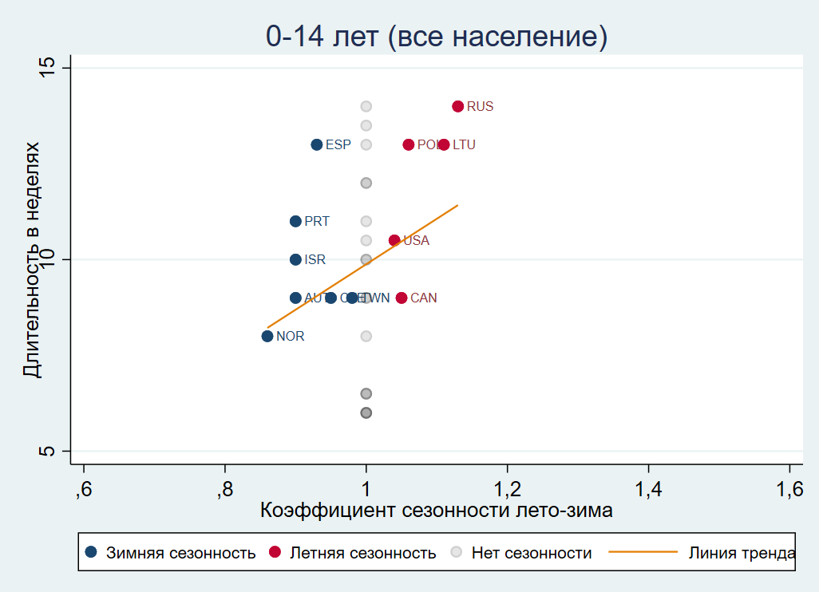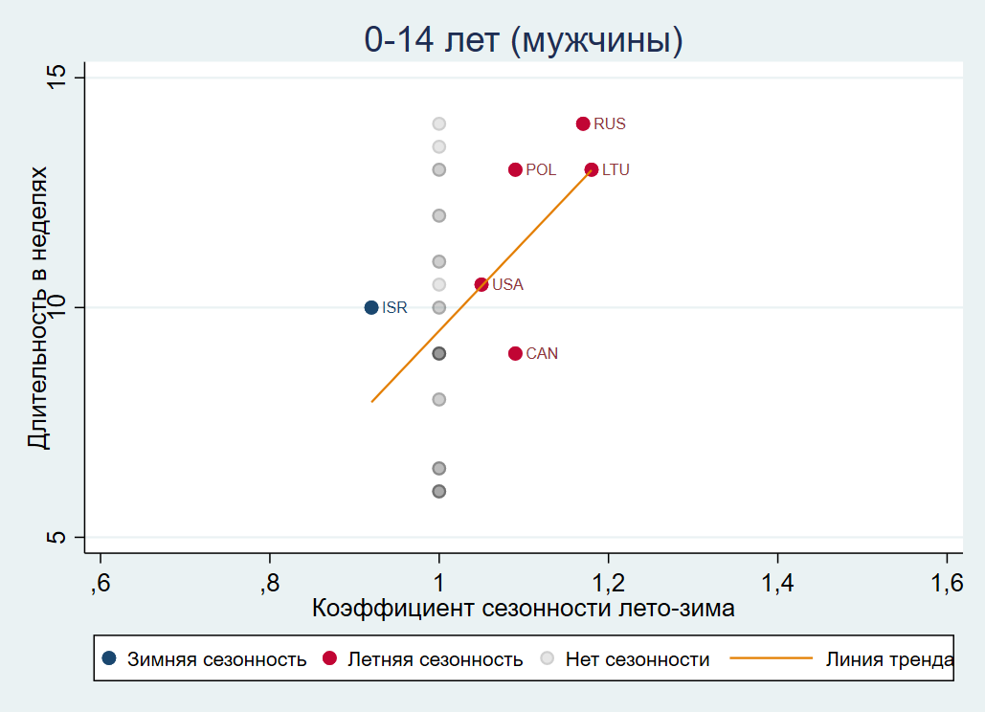
Graphically, a positive relationship between the duration of summer holidays and the summer seasonality of mortality in children and adolescents is confirmed, but certainly requires further empirical confirmation. It should also be noted that in most countries used for comparison, including those with a harsh climate, the duration of summer holidays is much less than in Russia.
Literature
Andrei, T., Mirică, A., Glăvan, I. R., Ferariu, G. A., & Radulescu-George, I. M. (2019, October). Seasonal adjustment of tourism data for Romania using JDemetra+. In Proceedings of the International Conference on Applied Statistics (Vol. 1, No. 1, pp. 8-16).
Asif, M., Nawaz, K., Zaheer, Z., Thygesen, H., Abu-Shaheen, A., & Riaz, M. (2019). Seasonality of deaths with respect to age and cause in Chitral District Pakistan. Plos one, 14(12), e0225994.
Chun, Heejung, and Michael Mobley. "Gender and grade-level comparisons in the structure of problem behaviors among adolescents." Journal of Adolescence 33.1 (2010): 197-207.
Grudkowska, S. (2015). JDemetra+ User Guide. Retrieved from: https://ec.europa.eu/eurostat/cros/system/files/jdemetra_user_guide.pdf.
Knyazev, G. G., Slobodskaya, H. R., Kharchenko, I. I., & Wilson, G. D. (2004). Personality and substance use in Russian youths: The predictive and moderating role of behavioural activation and gender. Personality and Individual Differences, 37(4), 827-843.
Nemtsov, A. V., & Fattakhov, T. A. (2021). Diagnostic and age composition of excess mortality associated with the New Year holidays in Russia. Population and Economics, 5, 1.
Weden, Margaret M., and Laurie S. Zabin. "Gender and ethnic differences in the co-occurrence of adolescent risk behaviors." Ethnicity and Health 10.3 (2005): 213-234.Lerchl, A. (1998). Changes in the seasonality of mortality in Germany from 1946 to 1995: the role of temperature. International journal of biometeorology, 42(2), 84-88.
Борискин, М. Л., Улесикова, И. В., Шатыр, Ю. А., Мулик, И. Г., Булатецкий, С. В., & Мулик, А. Б. (2018). Возрастные и гендерные особенности предрасположенности человека к рискованному поведению. Личность в меняющемся мире: здоровье, адаптация, развитие, 6(4 (23)), 741-756.
Родионова, Л. А., Копнова, Е. Д. (2019). Статистические подходы к анализу и моделированию сезонности в демографических данных. Демографическое обозрение, 6(2), 104-141.

