E.N. TIMUSHEV,
E.V. KOZONOGOVA,
J.V. DUBROVSKAYA,
Perm National Research Polytechnic University, Department of Economics and Finance, Perm, Komsomolsky Ave., 29

Assessment of the impact of shocks in healthcare on the labor market in a two-regional agent-oriented simulation model

One of the promising methodological techniques for predicting demographic changes at the regional level is agent-based modeling. It allows calculations to be carried out in the absence of analytical solutions for the socio-economic model. A less obvious advantage of simulation modeling is the possibility of obtaining quantitative characteristics of object heterogeneity at the micro level for subsequent use in evaluating general equilibrium models. Macroanalysis, based on the heterogeneity and optimization activity at the micro level, is usually carried out using dynamic stochastic general equilibrium models (DSGE models). This type of micromodels allows regional features and more realistic forecast scenarios.
This paper presents the results of modeling the impact of shocks in healthcare on the state of the labor market in a system consisting of two regions allowing migration between them. AnyLogic software product was used. In empirical testing of the model, actual data of the Perm Region and the Sverdlovsk Region for 2019-2021 are used.
The main trends in the labor market of these regions consist in increasing labor potential in the Perm Region and decrease of it in the Sverdlovsk region.
In our model lower agents represent a part (1000 people) of the population of the corresponding region. The regions themselves become agents of a higher level. The agent's state cycle covers one’s birth and death. The main attributes of agents are their social (child, person with disabilities, etc.) and labor statuses (Figure 1).

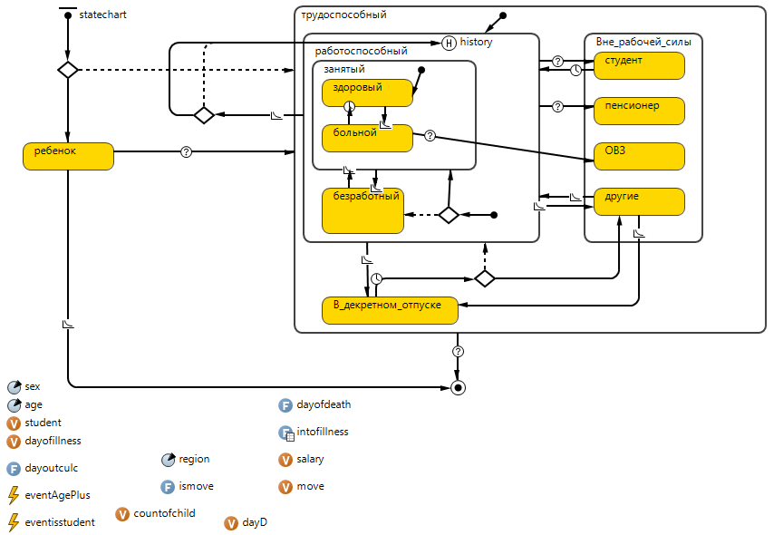

Figure 1 – Diagram of states, transitions and components of a lower agent representing a population unit

When constructing an agent-based simulation model, the main attention is paid to the artificial scale that allows changing the quality of the healthcare sector in the regions from "low" to "high" ("0.1" to "2.0"). A number of assumptions were also made. In particular, the migration of an individual agent to region j from region i occurs if the average salary in region j exceeds the current salary of the corresponding agent in region i with a probability of migration of 2%.
To perform calculations, the simulation model was filled with actual data for the Perm Region and the Sverdlovsk Region, as of January 1, 2019 or for 2019. The following groups of indicators were used:
- total population and age distribution, average nominal salary
- fertility and mortality rates (in particular, age-related fertility and mortality rates by sex, distribution of births by maternal age and the order of birth)
- indicators related to the labor market (in particular, retirement age, probability of job loss and employment by a person aged 16 and older)
- health indicators (in particular, average period of disability depending on age, frequency of cases of temporary disability during the year depending on age, the dynamics of disability).
To obtain quantitative data for population health indicators (except disability) we used data both from the literature and based on our own calculations. According to calculations, the lowest risk of morbidity is observed in the age category from 20 to 30 years, the highest – in the category from 30 to 50 years.
Calculations based on the constructed model in the AnyLogic program confirm the general trends in the regional labor markets. The results show that the total number of employees increases significantly with the improvement of the health care in each of the regions, but it is also possible to obtain specific quantitative estimates with a given change in the quality of the health care system. At the same time, the number of people outside the workforce decreases only under the prior negative dynamics in the labor market, as in the Sverdlovsk region.
The results obtained will be used later in DSGE modeling. Firstly, the projected number of employed people, reflecting the institutional characteristics of the regions, will be included in a refined production function. Secondly, the shocks in healthcare will be associated with the corresponding expenditures of the regional budgets within the budget constraints of the regional government sector.

The research was carried out based on the grant from the Russian Science Foundation № 21-78-10134, https://rscf.ru/project/21-78-10134/
version 8.8.0.

