Human Сapital of the Economically Active Population in Russia's Regions

Tatiana L. Klyachko,
Director, Centre for the Economics of Continuing Education
Director of the Centre for Continuing Education Economics of the Institute of Applied Economic Research of the Russian Academy of National Economy and Public Administration
of the Russian Academy of National Economy and Public Administration
(Presidential Academy, RANEPA)
Email: tatlk@bk.ru

The issue of linking education, human capital and economic growth has been the focus of research in recent decades. In principle, already in the works of T. Schultz and E. Denison, human capital is defined as the ability of labor to increase its contribution to economic growth due to its quality (using the example of the American economy [1]). G. Becker was the first to assess the economic efficiency of education, first of all, for the employee himself [2]. It should be noted that in Russia Academician S.G. Strumilin was the first to approach the concept close to the concept of "human capital" and assess its contribution to economic development in his work "Problems of Labor Economics" [3]. In it several sections are actually devoted to the analysis of human capital in its modern understanding, as well as the connection between qualified (quality) labour and education.
In recent years, the growing attention to human capital and the role of education in its formation is largely due to the increasing complexity of technology, as well as a certain acceleration of their changes, which naturally emphasize the importance of innovation and, consequently, of people in the modern economy. The rise of human capital to a leading position in economic development simultaneously draws attention to the education system as the system "responsible" for its production. At the same time, education is also seen as a system that builds certain filters on the individual's path through its levels. At the same time, the thesis that education, a high level of human capital development is not only a social good, but also the most important factor of economic development, has long been universally recognized [4]. However, expenditures (public and private) on education, the amount of human capital and the rate of economic growth are linked in a very complex way. A number of studies have found a correlation between these variables [5-7], while other studies have found the relationship to be either unstable or absent altogether [8].
This paper considers the indicator of the average number of years of education of the employed population as an indicator approximating human capital in the Russian regions. The disadvantages of such an indicator are well known. The duration of education does not always lead to an increase in the quality of education. The World Bank has shown in its construction of the Human Capital Index how the duration of education can be adjusted to consider the quality of education received by schoolchildren [9] or students [10].
The Russian regions have seen multidirectional changes in the value of the average number of years of education of the employed population. Since it is the employed population that produces GRP, it is important to assess how this indicator relates to other factors, including educational migration and post-education labour migration.
Figures 1 and 2 show subjects of the Russian Federation where the average number of years of education of the employed population is approaching its limit - these are the agglomerations of Moscow and Moscow Region, St. Petersburg, and Leningrad Region.
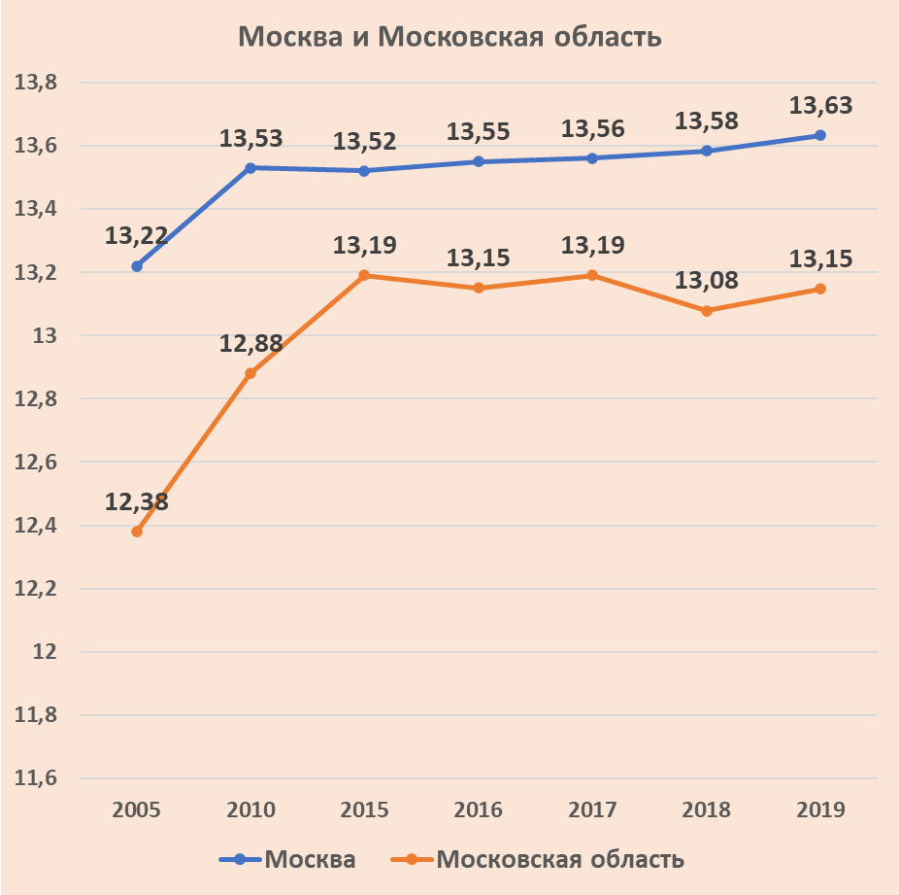
Figure 1 - Evolution of the average number of years of education for the employed population in Moscow and Moscow Region in 2005-2019, years

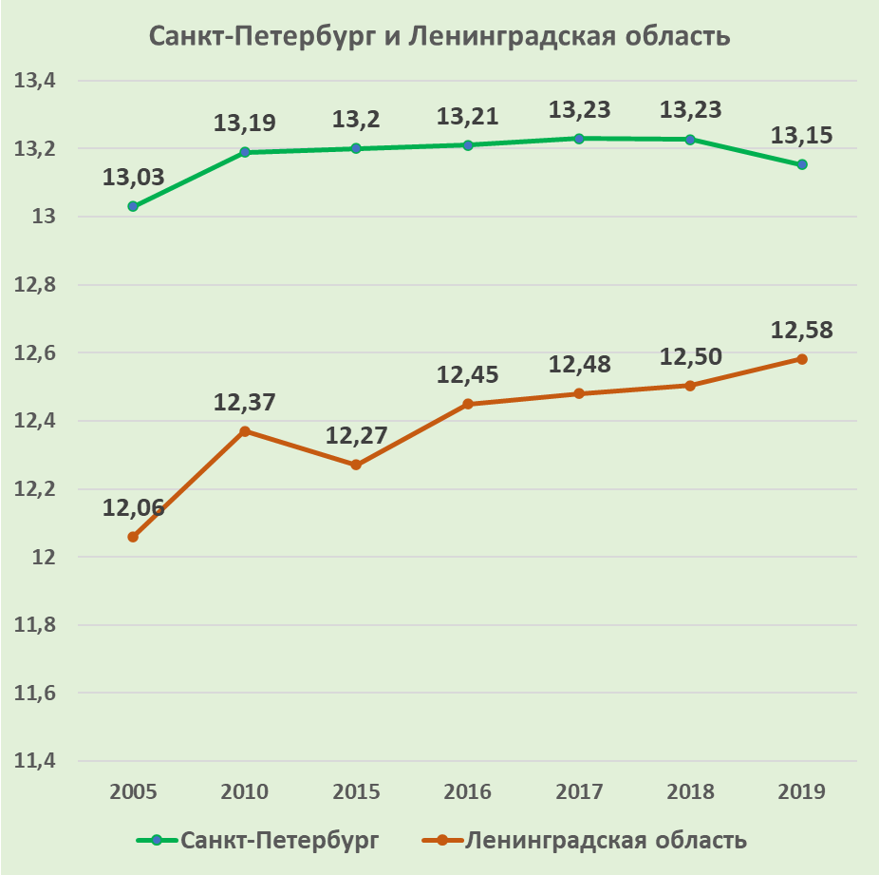
Figure 2 - Evolution of the average number of years of education of the employed population in St. Petersburg and the Leningrad Oblast in 2005-2019, years
The situation is different in other Russian regions: somewhere this indicator is growing, although slightly, and somewhere it has even begun to fall (Fig. 3).
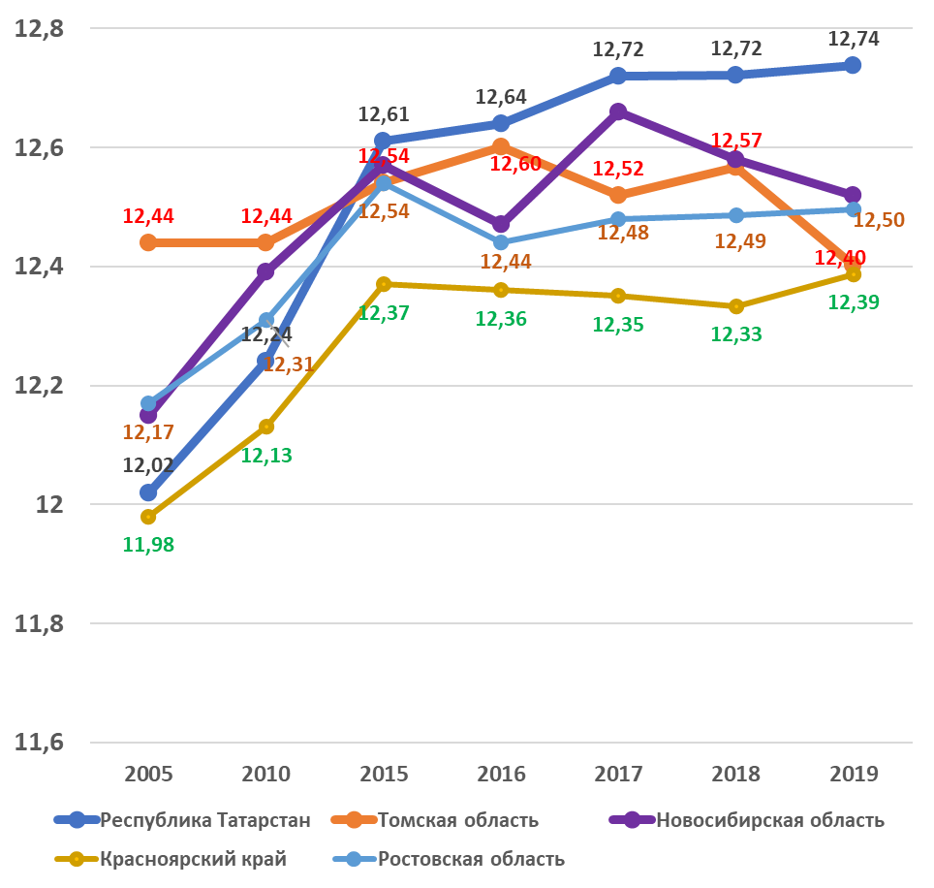
Figure 3 - Evolution of average number of years of education of employed population in some constituent territories of the Russian Federation in 2005-2019, years

Source: Rosstat calculations (Figures 1-3).

References
- 1 Shultz T. Human Capital in the International Encyclopedia of the Social Sciences. - N.Y., 1968, vol. 6.
- Becker G. Human Capital//N.Y.: Columbia University Press - 1964.
- S. G. Strumilin. Problems of Labor Economy. - Moscow: Nauka, 1982.
- Barro R., Sala-i-Martin X. Economic Growth, Chs 1 and 2//1995 - New York, McGraw Hill.
- Baldacci E., Clements B., Gupta S. & Cui Q. Social spending, human capital, and growth in developing countries/World Development. - 2008. - Vol. 36, №. 8, pp. 1317-1341.
- Loayza N.V., Raddatz C. (2010) The composition of growth matters for poverty alleviation//Journal of Development Economics, Elsevier. Vol. 93(1). Pp. 137-151
- Barro R., Lee J-W. (1996) International Measures of Schooling Years and Schooling Quality. American Economic Review, Papers and Proceedings, 86, 2, pp. 218-223.
- Pritchett L. Where has all education gone? World Bank Economic Review. - 2001. - № 3. P. 367-391.
- The Human Capital Project//2018 International Bank for Reconstruction and Development/The World Bank. - Washington, DC. - URL: https://worldbank.org/.
- The Human Capital Development Project, Year 2 - Progress Report. 2020 International Bank for Reconstruction and Development/World Bank.

