Regional industrial growth: contribution of the development institute

Evseeva M.V.
Institute for Statistical Studies and Economics of Knowledge, HSE, Moscow
Researcher, PhD in Economics, mvevseeva@hse.ru
Naumov I. V.
Institute of Economics, Russian Academy of Sciences, Ural Branch, Yekaterinburg
Head of modeling spatial development of territories laboratory, PhD in Economics
Starikov E. N.
Ural State University of Economic, Yekaterinburg
Associate Professor of Chess Art and Computer Mathematics, PhD in Economics

The technological development of the national economy is inextricably linked to the capabilities of regional industry. Because, ultimately, the realization of even the most advanced technologies faces on the availability of modern production facilities and personnel with the necessary level of skills. Therefore, regional manufacturing play a key role in technological development.
The main state development institute for the industrial sector is the Industrial Development Fund (hereinafter referred to as the Fund, IDF), which has proved its effectiveness. The Fund provides enterprises with preferential loans for the realization of investment projects. Priority goals for the Fund are technical re-equipment of production facilities, modernization, technological renewal of the material base, development and introduction of new production technologies at manufacturing enterprises. In the period 2015-2022, the Fund provided loans to 767 enterprises on 1,209 projects in the amount of RUB 329.7 billion. As a result, 566 enterprises increased or opened new production.
At the same time, we see only data on the amount of money that was issued and returned to the fund. This gives an indication of the effectiveness of the Fund, but does not give an idea of the overall effects - is there a general development of industry in the regions where enterprises have received support from the Fund?
The aim of the study is to find out how the Fund’s activity has influenced the development of industry in the regions of the Russian Federation.

Research design
The study period (2015 - 2021) was chosen taking into account the beginning of the Fund’s activities and available data.
Based on the aim, the target regions and a set of indicators to be assessed were identified. Thirty-five regions were excluded from the review - 12 of them had no IDF-supported projects, 23 of them had a single IDF-funded project, which could hardly have a visible impact on industrial growth. Manufacturing constraints were taken into account. The index of industrial production and volume of goods production of enterprises were used as indicators of industrial growth.
In order to eliminate the high degree of spatial heterogeneity, the regions were grouped into three groups by calculating the standard deviation from the average median of the annual average value of the projects realized with the participation of the IDF (Fig.1).

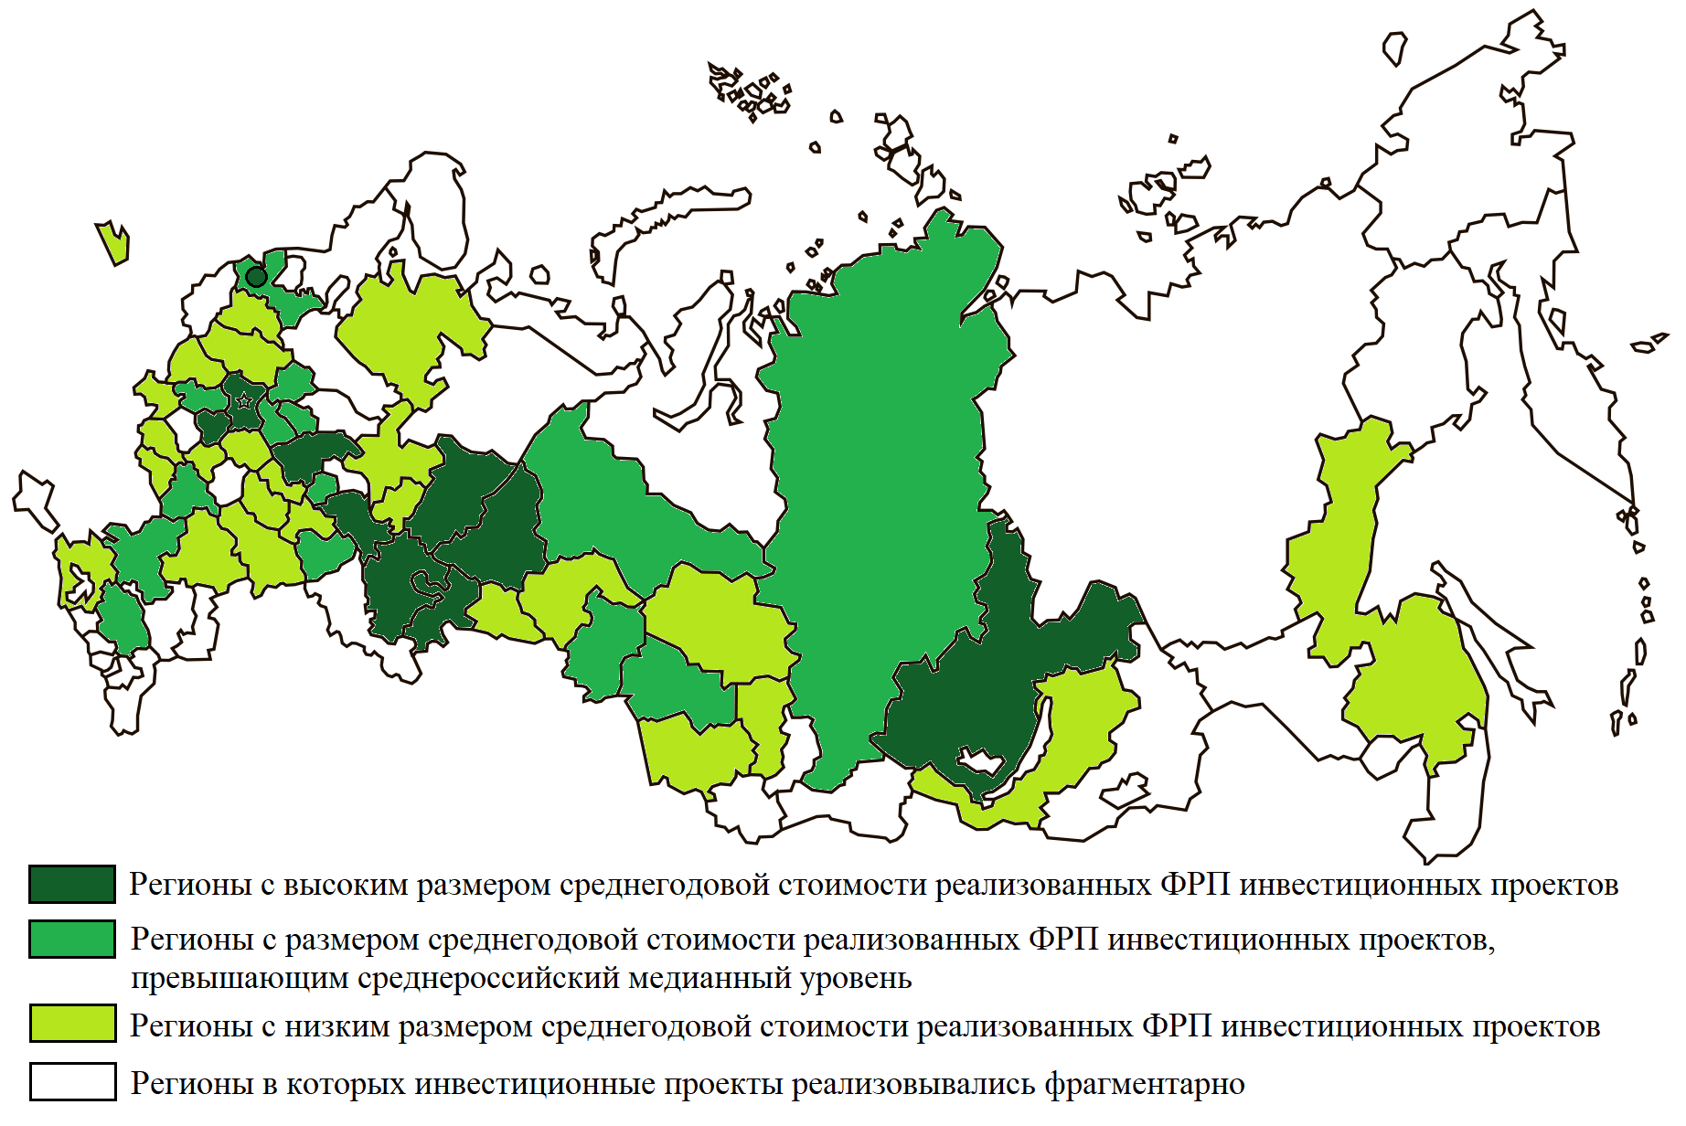
Fig.1 - The intensity of the Fund’s support to investment projects of industrial enterprises by region

For each group of regions, regression models were constructed using the least squares method based on panel data. Dependent variables - rate of growth of volume of goods shipped in manufacturing, index of industrial production. As a factor, the indicator of the ratio of the total value of investment projects realized with the support of IDF to the total amount of attracted investments in capital for the manufacturing industry of the region was used. Information base - data of Rosstat; data on 924 projects, supported by Fund, available on the official website of the Fund.
In the final stage, it was checked the conformity of the industry affiliation of projects supported by the fund, the technological specialization of the region. The sources of information was data from official websites of regional governments and the Atlas of Economic Specialization of the Russian Regions, HSE University.

Results and discussion
First of all, the regional grouping is very similar to most regional classifications based on the level of industrial development [see f.e., Urozhaeva and Ivanov, 2011; Akberdina, 2020]. The first group - are the regions with the highest level of industrial development and have a pronounced manufacturing profile, the II group has regions with medium level of industrial development, the III - regions with mining and industrial-agricultural profile of industry (fig. 1). It should be noted that the first group of regions accounted for 54 % of the total amount allocated by the Fund, 46 % - for other 39 regions of the sample.
The regression analysis shows a strong relationship between the factor and the dependent variables. The inverse relationship between the regions of group I and the direct dependence of different intensity for the regions of group II and III (table.2) have been found.
Table 2 - Relationship models between the indicators
Indicator | First group of regions (66 observations) | Second group of regions (84 observations) | Third group of regions (150 observations)
Index of industrial production | $$Y=e^{4,638}×X^{-0,0069}$$ | $$Y=e^{4,638}×X^{0,0041}$$ | $$Y=e^{4,631}×X^{0,0038}$$
Volume of goods production | $$Y=e^{4,684}×X^{-0,014}$$ | $$Y=e^{4,678}×X^{0,0149}$$ | $$Y=e^{4,68}×X^{0,014}$$

Thus, in regions where more than half of the Fund’s disbursements are concentrated, there is a negative correlation between the value of projects supported by the Fund and industrial growth.
The qualitative assessment of the sectoral focus of the projects supported by the Fund led to the following conclusions.
1. The discrete nature of the Fund’s support cannot be the basis for the systematic development of regional industry. When making a decision on the allocation of funds, the Fund is guided only by the parameters of the project and the reliability of the borrower, without taking into account the regional context (for example, industry specialization of the region, state of its infrastructure) and the priorities of development region.
2. Taking into account the data presented in the Atlas, we can see that the regions of group I are characterized by a wide specialization and high degree of industries connectedness, while the regions of groups II and III are characterized by narrow specialization and low degree of industries connectedness. The analysis of the industry affiliation of the projects supported by the Fund in the regions of Groups II and III showed that in half of the cases, the projects were implemented in non-core industries for the regions. Given the positive correlation between support levels and industrial growth, these projects can be assumed to have become regional industry growth points. Initiating the development of a new, non-core activity for the region allows converting the resources of the territory into industrial growth.
3. The regions of Group I appear to be self-developing due to the multiplicity of linkages and the resulting network effects, so the Fund’s support of projects in these regions has no impact on industrial development.

Thus, we suppose that the Industrial Development Fund can become a systemic instrument to support industrial growth in medium-development industrial regions. Supporting the development of new industries for the region will stimulate the formation of new linkages and thus the emergence of positive network effects in the economy.

References

Akberdina V. V. (2020). Multifunctional Role of Industrial Regions in the Economy // Journal of New Economy. T. 21, 3. P. 48-72.
Urozhaeva Y. V., Ivanov D. S. (2011). Problems of classification of regions: international and Russian experience // Russian regions: economic crisis and modernization problems / under ed. L. M. Grigorieva, N. V. Zubarevich, G. R. Hasaeva
Atlas of economic specialization of the Russian regions / V. L. Abashkin, L. M. Gochberg, J. Y. Epherin et al. under Ed. L. M. Gochberg, E. S. Kutsenko; M.: NYU HSE, 2021. - 264 p

https://www.hse.ru/mirror/pubs/share/459686396.pdf

